七上英语暑假预习Unit 1~7固定搭配
Unit 1 You and Me
make friends——交朋友
例句：I want to make friends with people from different countries.
be nice to——对……友好
例句：She is always nice to her classmates.
say hello to——向……打招呼
例句：He always says hello to his teachers when he sees them.
come from——来自
例句：I come from Beijing.
be good at——擅长
例句：She is good at playing the piano.
listen to music——听音乐
例句：I like to listen to music in my free time.
play sports——做运动
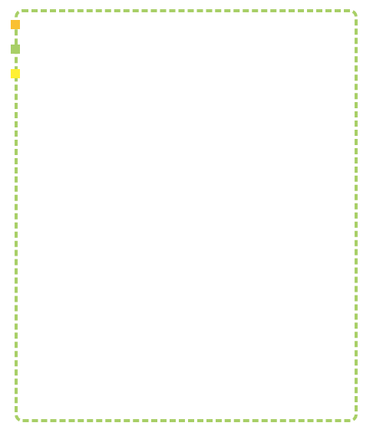
例句：We often play sports after school.
in the same class——在同一个班级
例句：We are in the same class and we are good friends.
Unit 2 We're Family!
have a big family——有一个大家庭
例句：I have a big family with many relatives.
love each other——彼此相爱
例句：In my family, we all love each other very much.
help with——帮助做某事
例句：I often help my mother with the housework.
look after——照顾
例句：My sister looks after our little brother when our parents are busy.
be busy with——忙于某事
例句：My father is busy with his work every day.
talk to——与……交谈
例句：I like to talk to my grandparents about my school life.
spend time with——与……共度时光
例句：We spend a lot of time together on weekends.
get on well with——与……相处融洽
例句：I get on well with my classmates and teachers.
Unit 3 My School
in front of——在……前面
例句：There is a big tree in front of our school.
next to——紧挨着
例句：The library is next to the classroom building.
go to school——去上学
例句：I usually go to school by bike.
have lessons——上课
例句：We have four lessons in the morning.
in the classroom——在教室里
例句：The students are reading books in the classroom.
on the playground——在操场上
例句：We often play football on the playground.
be far from——离……远
例句：My home is far from my school, so I take the bus to school.
show... around——带领……参观
例句：Let me show you around our school.
Unit 4 My Favourite Subject
favourite subject——最喜欢的科目
例句：My favourite subject is English.
be interested in——对……感兴趣
例句：I am interested in science and I want to be a scientist.
learn about——了解
例句：We learn about different cultures in our geography class.
do well in——在……方面做得好
例句：She does well in maths and always gets good grades.
have fun——玩得开心
例句：We have a lot of fun in our PE class.
find out——查明，发现
例句：I need to find out more information about this topic.
be useful for——对……有用
例句：Learning English is useful for my future career.
look forward to——期待
例句：I am looking forward to the summer vacation.
Unit 5 Fun Clubs
join a club——加入俱乐部
例句：I want to join the music club.
be good with——善于应付……的；对……有办法
例句：She is good with children and she wants to be a teacher.
play chess——下棋
例句：My father likes to play chess with me on weekends.
tell stories——讲故事
例句：Our teacher often tells us interesting stories in class.
play the guitar——弹吉他
例句：He can play the guitar very well.
on the weekend——在周末
例句：I usually go shopping with my friends on the weekend.
need help with——需要帮助做某事
例句：I need help with my English homework.
make a poster——制作海报
例句：We are going to make a poster for the school club fair.
Unit 6 A Day in the Life
get up——起床
例句：I usually get up at six o'clock in the morning.
brush one's teeth——刷牙
例句：Don't forget to brush your teeth before going to bed.
have breakfast——吃早餐
例句：I have breakfast with my family every morning.
go to bed——上床睡觉
例句：I go to bed at ten o'clock every night.
do one's homework——做作业
例句：I need to do my homework after dinner.
take a shower——洗澡
例句：I take a shower every day to keep clean.
watch TV——看电视
例句：We often watch TV together in the evening.
be late for——迟到
例句：Don't be late for school again.
Unit 7 Happy Birthday！
birthday party——生日聚会
例句：We are having a birthday party for my sister this weekend.
make a wish——许愿
例句：Before blowing out the candles, she made a wish.
blow out——吹灭
例句：He blew out all the candles on his birthday cake.
cut up——切碎
例句：Can you help me cut up the vegetables for the salad?
bring... to——把……带到
例句：Please bring your books to class tomorrow.
a piece of——一片/块/张……
例句：I would like a piece of cake, please.
be full of——充满
例句：The room is full of balloons and decorations for the party.
have a good time——玩得开心
例句：I hope you have a good time at the party.

