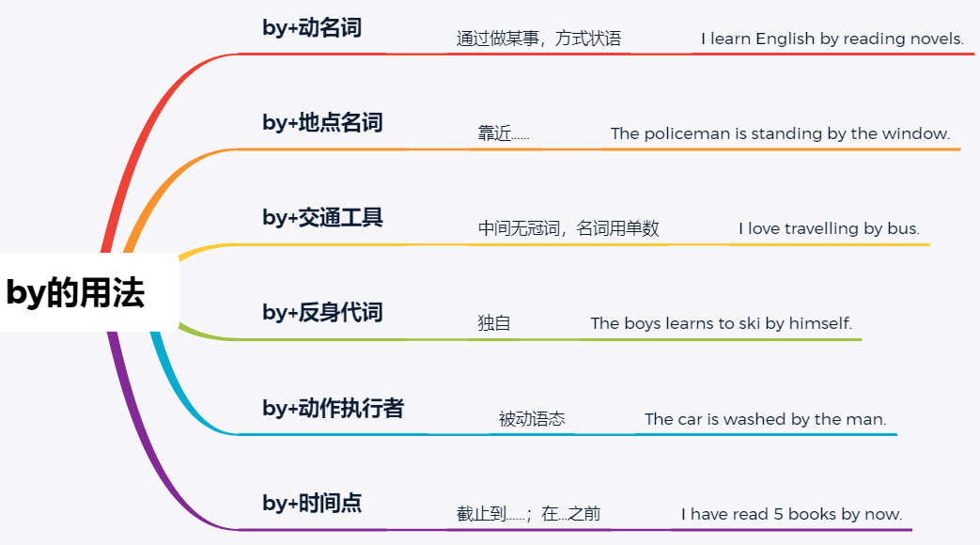
九年级英语全一册Unit1语法重点by的用法

1、“by+时间点”的动词时态：
（1）后接过去的时间，多与过去完成时连用。
例：They had finished thier work by the end of last week.
到上周末他们已经完成了工作。
（2）后接now时，多与现在完成时连用。
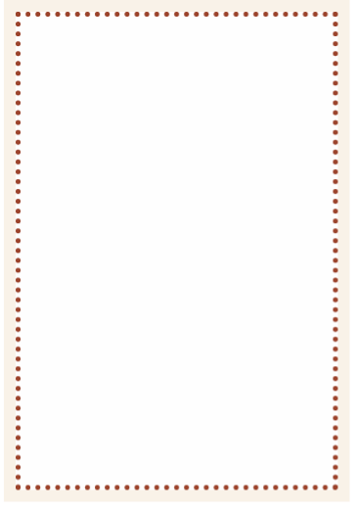
例：Maybe she has returned by now.
或许现在她已经回来了。
（3）后接将来的时间，多与一般将来时或将来完成时连用。
例：I'll be there by five o'clock this afternoon.
我今天下午五点以前到那里。

2、介词by的其他用法：
（1）表示原因（名词前不加冠词）
如by chance、by mistake、by accident、by luck、by reason of、by design。
例：They met by chance.他们不期而遇。
例：I did it by mistake.我误做了这件事。
（2）表示通过某种方式（名词前不加冠词）
如by phone、by hand、by machine、by radio...。
（3）“by+身体部位名词/衣服名词”表示“被抓住身体/衣物的某一部分”常与动词catch/seize/hold/grab等连用（名词前需加冠词）。
例：The policeman caught the thief by the arm.
警察抓住了小偷的胳膊。
例：I took him by the hand.
我拉着他的手。
（4）用于乘除运算
例：6 multiplied by 3 equals 18. 6乘以3等于18。
例：6 divided by 3 equals 2. 6除以3等于2。

3、by构成的介词短语作方式状语时，对其提问应用疑问词How。
例：—How do you study for a test?
—你是如何准备考试的？
—By working hard. —通过努力学习。
【妙思巧计】
by的用途真不少，掌握起来却不难。
by若加上“时间点”，完成时态用得多。
“by+动名词”表方式，用how提问记心间。
“交通工具”若用by，切记无冠且必单。
“独自”、“单独”是什么，“by+反身代词”来解释。
“by+动作执行者”表被动，一定牢牢记心田。

【同步检测】
1、I can do it by myself (I).
2、We go to Beijing by bus (bus).
3、This work is finished by hand (hand).
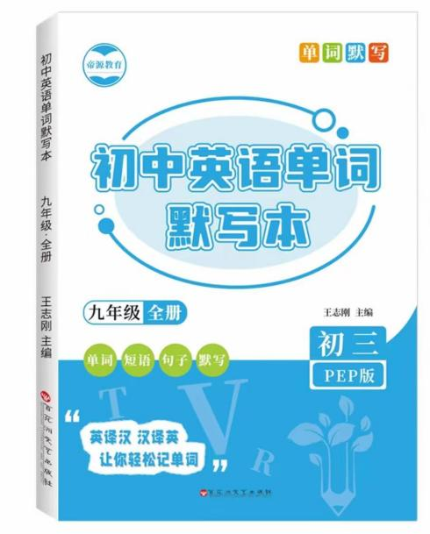
4、I think you can improve your English by watching (watch) English movies.
视频同款学习资料
想要的家长看主页橱窗
选中小学教辅图书
全网搜“帝源教育”

5、Water is changed into steam by heat (hot) and into ice by cold
6、春节过后，天气逐渐变暖和了。
The weather gets warm bit by bit after the Spring Festival.
7、王力喜欢逐字阅读，所以他是个很慢的阅读者。
Wang Li likes reading word by word, so he is a slow reader.
8、你通过听英文歌曲来学英语吗？
Do you learn English by listening to English songs?
9、learns, by, he, French, reading aloud
He learns French by reading aloud.
10、was, Teahouse, by, written, Lao She
Teahouse was written by Lao She

