2025新版八上英语Unit1词汇与语法特训
一、词汇运用
(一) 根据句意及首字母提示补全单词
1. We saw many ancient buildings when we visited Paris last summer.
2. The food in Chengdu was so delicious that we ate it every day.
3. I kept a travel journal to record all the wonderful moments.
4. The scenery from the mountain top was really breathtaking.
5. They decided to experience the local culture by living with a native family.
(二) 用所给词的适当形式填空
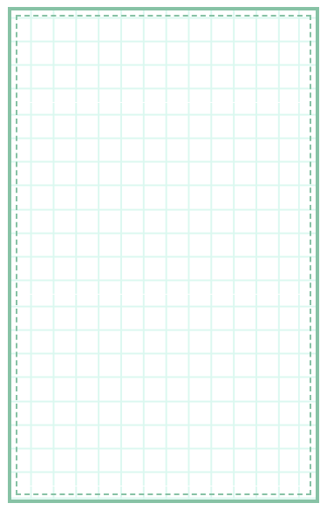
6. After hiking (hike) for three hours, we finally reached the temple.
7. My sister enjoys collecting (collect) seashells on the beach.
8. We were swimming (swim) in the hotel pool when it started to rain.
9. This is the best (good) vacation I've ever had in my life.
10. The tour guide asked us not to feed (not feed) the animals in the zoo.

二、语法综合
(一) 单项选择
（ B ）11. —______ did you go on vacation?
—I went to Sanya with my parents.
A. When B. Where C. How D. Why
（ B ）12. The weather in London was ______ than we expected.
A. bad B. worse C. worst D. badly
（ C ）13. We decided ______ to the museum because it was free on Sundays.
A. go B. going C. to go D. went
（ C ）14. —Who taught you French?
—______. I learned it by myself.
A. Someone B. Anyone C. No one D. Everyone
（ C ）15. I felt ______ after the long flight, so I went straight to bed.
A. excite B. exciting C. exhausted D. exhausting
(二) 句型转换
16. She bought some special gifts for her friends. (改为一般疑问句)
Did she buy any special gifts for her friends?
17. They stayed in Tokyo for two weeks. (对划线部分提问)
How long did they stay in Tokyo?
18. The trip was fantastic. (改为感叹句)
What a fantastic trip it was!
19. To try local food is important when traveling. (改为同义句)
It's important to try local food when traveling.
20. He went to bed after he finished packing. (用not...until改写)
He didn't go to bed until he finished packing.

三、语篇训练
(一) 完形填空
Last summer, my family and I visited Guilin. It was our first time there. The city is famous 21 its amazing limestone mountains and clear rivers. We 22 a boat trip along the Li River. The scenery was so beautiful that I took over a hundred photos. Our guide told us 23 interesting stories about the local culture. The most exciting part was when we tried rock climbing. At first, I felt 24 , but my father encouraged me to keep trying. After I reached the top, the view was absolutely worth the effort. This trip taught me 25 to face challenges bravely.
（ A ）21. A. for B. as C. to D. with
（ C ）22. A. take B. takes C. took D. taking
（ A ）23. A. many B. much C. few D. little
（ A ）24. A. nervous B. excited C. happy D. bored
（ C ）25. A. what B. when C. how D. where


视频同款学习资料
想要的家长看主页橱窗
选中小学教辅图书
全网搜“帝源教育”

四、书面表达
假设你暑假去海南旅游，请根据以下提示写一篇80词左右的游记：
1. 天气和环境
2. 主要活动（至少两项）
3. 感受或收获
【参考范文】
This summer I visited Hainan. The weather was sunny and the beach was beautiful. I tried two exciting activities: surfing and snorkeling. At first, surfing was difficult but my teacher helped me stand on the board. When snorkeling, I saw colorful fish and coral reefs. I also tasted delicious seafood like grilled fish and coconut rice. This trip made me appreciate nature more and I want to go back next year!
2025新版八上英语Unit1词汇与语法特训
一、词汇运用
(一) 根据句意及首字母提示补全单词
1. We saw many ancient buildings when we visited Paris last summer.
2. The food in Chengdu was so delicious that we ate it every day.
3. I kept a travel journal to record all the wonderful moments.
4. The scenery from the mountain top was really breathtaking.
5. They decided to experience the local culture by living with a native family.
(二) 用所给词的适当形式填空
6. After hiking (hike) for three hours, we finally reached the temple.
7. My sister enjoys collecting (collect) seashells on the beach.
8. We were swimming (swim) in the hotel pool when it started to rain.
9. This is the best (good) vacation I've ever had in my life.
10. The tour guide asked us not to feed (not feed) the animals in the zoo.

二、语法综合
(一) 单项选择
（ B ）11. —______ did you go on vacation?
—I went to Sanya with my parents.
A. When B. Where C. How D. Why
（ B ）12. The weather in London was ______ than we expected.
A. bad B. worse C. worst D. badly
（ C ）13. We decided ______ to the museum because it was free on Sundays.
A. go B. going C. to go D. went
（ C ）14. —Who taught you French?
—______. I learned it by myself.
A. Someone B. Anyone C. No one D. Everyone
（ C ）15. I felt ______ after the long flight, so I went straight to bed.
A. excite B. exciting C. exhausted D. exhausting
(二) 句型转换
16. She bought some special gifts for her friends. (改为一般疑问句)
Did she buy any special gifts for her friends?
17. They stayed in Tokyo for two weeks. (对划线部分提问)
How long did they stay in Tokyo?
18. The trip was fantastic. (改为感叹句)
What a fantastic trip it was!
19. To try local food is important when traveling. (改为同义句)
It's important to try local food when traveling.
20. He went to bed after he finished packing. (用not...until改写)
He didn't go to bed until he finished packing.

三、语篇训练
(一) 完形填空
Last summer, my family and I visited Guilin. It was our first time there. The city is famous 21 its amazing limestone mountains and clear rivers. We 22 a boat trip along the Li River. The scenery was so beautiful that I took over a hundred photos. Our guide told us 23 interesting stories about the local culture. The most exciting part was when we tried rock climbing. At first, I felt 24 , but my father encouraged me to keep trying. After I reached the top, the view was absolutely worth the effort. This trip taught me 25 to face challenges bravely.
（ A ）21. A. for B. as C. to D. with
（ C ）22. A. take B. takes C. took D. taking
（ A ）23. A. many B. much C. few D. little
（ A ）24. A. nervous B. excited C. happy D. bored
（ C ）25. A. what B. when C. how D. where

视频同款学习资料
想要的家长看主页橱窗
选中小学教辅图书
全网搜“帝源教育”

四、书面表达
假设你暑假去海南旅游，请根据以下提示写一篇80词左右的游记：
1. 天气和环境
2. 主要活动（至少两项）
3. 感受或收获
【参考范文】
This summer I visited Hainan. The weather was sunny and the beach was beautiful. I tried two exciting activities: surfing and snorkeling. At first, surfing was difficult but my teacher helped me stand on the board. When snorkeling, I saw colorful fish and coral reefs. I also tasted delicious seafood like grilled fish and coconut rice. This trip made me appreciate nature more and I want to go back next year!

