七上英语Unit 2单元主题写作及范文
单元主题写作：围绕“家庭”展开
（一）
你校社团计划举办以“I Love My Family”为题的征文活动，假如你是李华，请根据以下提示，用英语写一篇短文投稿，谈谈你的家庭情况，词数80词左右。
★【范文】
I Love My Family
Hi, |’ m li Hua. l have a nice family. There are three people in it: my dad, my mom, and me.
My dad is 45. He’s an engineer. He builds bridges and roads. n his free time, he likes reading and traveling. My mom is 43.She’s a teacher. She teaches English at school. She loves cooking and playing sports. When she is free, she often does somerunning. "’m 15. 1’m a student. ike science and math, l also love plaving basketball and spending time with my family, We watch
movies and go hiking together on weekends.
I'm happy to have such a great family. l love them very much!
★【翻译】
我爱我的家人
嗨，我是李华。我有一个温馨的家庭。家里有三口人：我爸爸、我妈妈和我。
我爸爸45岁。他是一名工程师。他建造桥梁和道路。在空闲时间，他喜欢阅读和旅行。我妈妈43岁。她是一名教师。她在学校教英语。她喜欢烹饪和运动。有空时，她经常去跑步。“我15岁。我是一名学生。我喜欢科学和数学，我也喜欢打篮球和和家人在一起。我们经常一起观看
一起看电影，周末一起去徒步旅行。
我很高兴有这样一个美好的家庭。我非常爱他们！
七上英语Unit 2单元主题写作及范文
单元主题写作：围绕“家庭”展开
（二）
请以“Zhang Yuan’s Family”为题写一篇英语短文，介绍一下你朋友张媛的家庭。她今年15岁，是初三(3)班学生。她家有四口人——父母、姐姐和张媛。她爸爸是你们学校的英语老师，妈妈是医生，姐姐是护士。周末她和她的家人经常聚在一起进行家庭活动，她很爱她的家。
写作要求：
1. 文中须包含所有的要点提示，可以适当发挥；
2. 文中不得出现考生的真实姓名和学校名称；
3. 词数70个左右。
★【范文】
Zhang Yuan's Family
Zhang Yuan is a 15-year-old student in Class 3, Grade 9. There are four people in her family: her parents, her elder sister, andherself. Her father is an English teacher at our school. Her mother works as a doctor and her sister is a nurse.
On weekends, Zhang Yuan and her family often spend time together doing fun activities. She loves her family very much. Theyare a happy and busy family.
★【翻译】
张元的家人
张媛是一名15岁的九年级三班学生。她家有四口人：她的父母、姐姐和她自己。她的父亲是我们学校的一名英语老师。她的母亲是一名医生，姐姐则是一名护士。
周末，张媛和她的家人经常一起度过时光，做些有趣的活动。她非常爱她的家人。他们是一个快乐而忙碌的家庭。
七上英语Unit 2单元主题写作及范文
单元主题写作：围绕“家庭”展开
（三）
假如你是李欣，你需要给你的美国笔友Lucy回一封信，简单的介绍一下你自己、你的家庭及你的学校生活情况。根据以下内容提示完成信件。
内容提示：
How many people are there in your family and who are they?
What do you like doing with your family?
Is there anything interesting about your new school life?
★【范文】
Dear Lucy,
Thanks for your letter. '’ m Li Xin. There are four people in my family. They are my parents, my younger brother and me. l likegoing for a picnic with my family on weekends. We enjoy the beautiful scenery and delicious food together.
My new school life is very interesting. We have many clubs at school. l joined the Art Club because l love drawing. Myclassmates are friendly and the teachers are kind. We often have group activities and it helps us learn better.
That' s all. Thank you.
Yours
Li Xine
★【翻译】
亲爱的露西，
谢谢你的来信。我是李欣。我家有四口人。他们是我的父母、弟弟和我。我喜欢在周末和家人一起去野餐。我们一起欣赏美丽的风景，享受美味的食物。
我的新学校生活非常有趣。学校里有很多社团。我加入了艺术社团，因为我喜欢画画。我的同学们都很友好，老师们也很和蔼。我们经常进行小组活动，这有助于我们更好地学习。
就这样了。谢谢。
你的，李希恩
七上英语Unit 2单元主题写作及范文
单元主题写作：围绕“家庭”展开
（四）
新的启程，新的起点，在初中生活里我们面临新的挑战、新的环境，也迎来了新的朋友。请写至少5句话介绍你自己，内容包括：姓名、年龄、家庭、兴趣爱好等。
要求：
(1) 可适当增加细节，以使行文连贯；
(2) 文中不得出现真实人名和校名。
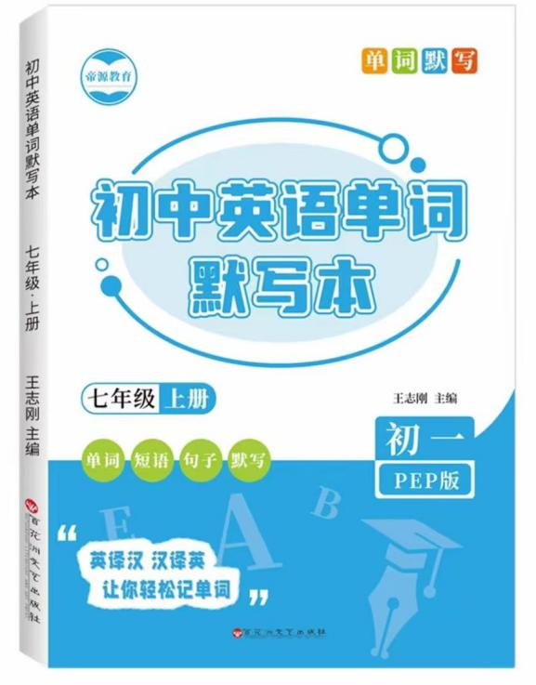
视频同款学习资料
想要的家长看主页橱窗
选中小学教辅图书
全网搜“帝源教育”

★【范文】
My name is Lily Smith. l am thirteen years old. l live with my parents, my older sister, and my little brother. l likereading books and playing basketball in my free time. l also enjoy listening to music. l hope to make many new friendshere.
★【翻译】
我叫莉莉·史密斯。我今年十三岁。我和父母、姐姐以及弟弟住在一起。在空闲时间，我喜欢看书和打篮球。我也喜欢听音乐。我希望在这里结交许多新朋友。

