八年级英语上册Unit 2单元主题写作记范文
单元主题写作：“家”

❤（一）
假如你是李辉，你们班正在举行一个名为“家的记忆”的主题班会，请回忆发生在你家的一件有意义的事情，写一篇英语短文向同学们分享。
❤【范文】
Family Memories
Hi, everyone.l am very happy to share a heartwarming memory. Last Mid-Autumn Festival, my whole family gathered on ourbalcony to admire the full moon. My grandmother told the legend of Chang’ e, while my father played the quitar softly. Myyounger brother and l helped mother arrange mooncakes and fruits on the table. The silver moonlight mixed with the goldenlantern light created a magical atmosphere
This memory includes my parents, grandmother, brother and me. Though simple, it taught me that family bonding is life’ ssweetest gift. The shared laughter and stories under the moonlight will forever warm my heart.
❤【翻译】
家庭回忆
大家好。我很高兴与大家分享一段温馨的回忆。去年中秋节，我们全家聚集在阳台上赏月。祖母给我们讲述了嫦娥的传说，父亲则轻轻地弹奏着吉他。弟弟和我帮妈妈把月饼和水果摆放在桌子上。银色的月光与金色的灯笼灯光交织在一起，营造出一种神奇的气氛
这段记忆包括我的父母、祖母、哥哥和我。虽然简单，但它教会了我家庭纽带是生命中最甜蜜的礼物。在月光下分享欢笑和故事，将永远温暖我的心。
八年级英语上册Unit 2单元主题写作记范文
单元主题写作：“家”
❤（二）
劳动教育是学生全面发展的重要组成部分。在日常生活中，青少年应该参加各项劳动，在实践中习得劳动知识，掌握劳动技能，形成良好的劳动习惯。假如你是英语俱乐部的成员，俱乐部这周的分享话题是“家务劳动实践”。请你参考提示信息以及自身的经历，写一篇发言稿与大家分享。
❤【范文】
For middle school students, doing housework should be part of life. it’s necessary for us to do some chores like taking out therubbish and sweeping the floor.
As for me, l wash my socks every day and do the dishes about twice a week. l wash my clothes every Friday evening, andsometimes l cook dinner on Saturday. Every Sunday, l spend the whole afternoon cleaning up my bedroom.Doing housework gives me a sense of pride.l can also learn some useful life skils. it also helps me relax after a day's study.
All in all, everyone should spend some time sharing chores at home.
❤【翻译】
对于中学生而言，做家务应该是生活的一部分。我们有必要做一些家务，比如倒垃圾和扫地。
至于我，我每天都会洗袜子，每周大约洗两次碗。我每周五晚上洗衣服，有时周六会做饭。每个周日，我会花一整个下午的时间打扫卧室。做家务让我有自豪感。我还能学到一些有用的生活技能。这也有助于我在一天的学习后放松身心。
总而言之，每个人都应该花些时间分担家务。
八年级英语上册Unit 2单元主题写作记范文
单元主题写作：“家”
❤（三）
请根据下面的信息写一篇英语短文，以“Family Cleaning”为题，描述一次家庭大扫除活动。要点如下：（1）时间：周六上午；地点：家里；人物：全家人。（2）具体分工：爸爸负责打扫地板和清理窗户，妈妈整理房间和洗衣服，我和弟弟收拾玩具和书籍。（3）感受：我们都很有成就感，希望以后多进行这样的活动。
❤【范文】
Family Cleaning
Last Saturday morning, my family had a big cleanup at home. Everyone took part in it.
First, we divided the tasks. My father was in charge of sweeping the floor and cleaning the windows. My mother tidied up therooms and did the laundry. My litle brother and l were responsible for putting away toys and books. During the cleaning, thoughwe were a bit tired, there was laughter all the time.
Finally, our home became clean and tidy. We all felt a strong sense of achievement. l hope we can have more such meaningfulactivities in the future.
❤【翻译】
家庭清洁
上周六早上，我们全家在家里进行了一次大扫除。每个人都积极参与其中。
首先，我们分配了任务。我父亲负责扫地和擦窗户。我母亲负责整理房间和洗衣服。我和我的小弟弟负责收拾玩具和书籍。在打扫过程中，虽然我们有点累，但笑声一直不断。
最后，我们的家变得干净整洁。我们都感到了一种强烈的成就感。我希望我们将来能举办更多这样有意义的活动。
八年级英语上册Unit 2单元主题写作记范文
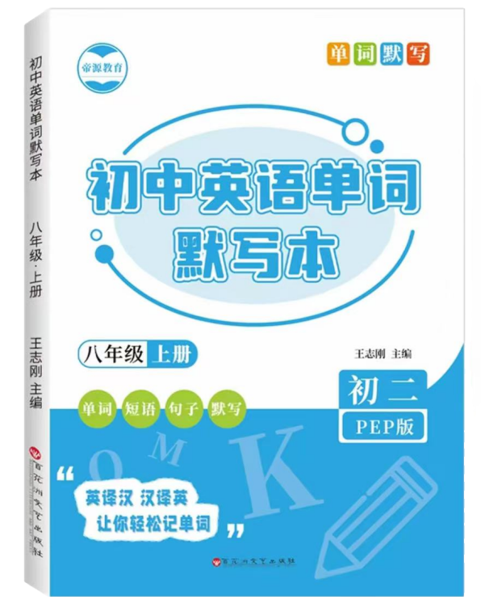
单元主题写作：“家”
❤（四）
视频同款学习资料
想要的家长看主页橱窗
选中小学教辅图书
全网搜“帝源教育”

❤【范文】
Home, Sweet Home
There is an old saying, "East or west, home is the best." l live in a house in the countryside. There'’s a big living room, threebedrooms. a kitchen and a bathroom in it. There’ re some trees and flowers around my house. The air is really clean. And l oftenhear birds sing.
There are four people in my family. They’re my parents, my sister and me. We’re helpful and friendly. And we always helpand get on well with each other.
I’m happy l have a good family. l will try my best to do more housework and farm work. And !’ ll study harder so that l canmake more money in the future. |'m sure my home will be better and better.
❤【翻译】
家，温馨的家
有句老话说：“无论东西南北，家是最好的。”我住在乡下的房子里。房子里有一个大客厅、三间卧室、一间厨房和一间浴室。房子周围有一些树和花。空气真的很干净。我经常听到鸟儿在唱歌。
我家有四口人。他们是我的父母、姐姐和我。我们乐于助人，待人友善。我们总是互相帮助，相处融洽。
我很高兴我有一个幸福的家庭。我会尽我所能多做一些家务和农活。而且，我会更加努力学习，以便将来能赚更多的钱。我相信我的家会变得越来越好。

