2025新版八上英语Unit1话题写作及范文
《Unit 1 Happy Holiday》
❤【单元话题】
本单元的主题是“欢乐假期”，要求学生能运用所学的词汇和句型介绍假期活动。写作中以一般过去时为主，需围绕假期经历的意义、见闻感受等展开，比如写假日日记记录生活、给朋友写信分享假期故事。

❤【写作素材】
【词汇积累】
1.take sb’s breath away 令人惊叹；让人叹绝
2.steamed chicken soup汽锅鸡
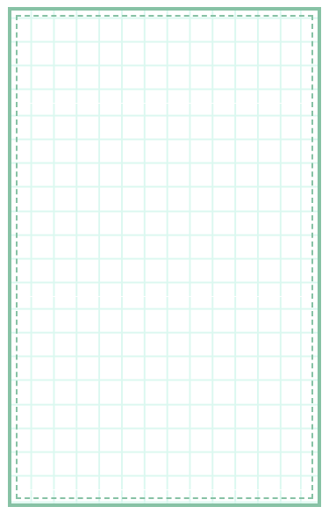
3.nothing but 只有；只是
4.ready to do sth. 马上要（做某事）；愿意做（某事）
5.get together 聚会；相聚
6.turn around 转身；翻转
7.look for 寻找
8.visit some ancient buildings 参观一些古建筑
9.go to a summer camp 参加夏令营
10.as a gift 作为礼物
11.rain heavily 下大雨
12.arrive at（+小地点/in+大地点）到达......
13.in different ways 以不同的方式
14.take a train to... 乘火车去......
15.on the last day 在最后一天
16. feel excited to do sth. 感觉做......是兴奋的
17. make a noise 制造噪音

【句型积累】
1. We stayed in the old town for a few days, and we enjoyed it very much. （for+时间段表示持续）
我们在老城区呆了几天，我们非常喜欢。
2. We took a lot of great photos there. （take photos）
我们在那里拍了很多很棒的照片。
3. I could do nothing but stay in the hotel. （nothing but）
我只能呆在酒店里。
4. I was so bored that I decided to find to read. （decide to do）
我无聊极了，决定找个地方看书。
5. It was such a good experience! （such +a\\an +adj.+名词单数）
这是一次很好的经历！
6. Then you can go back to your regular life, and be ready to see what comes next. （ ready to do）
然后你可以回到你的日常生活，并准备好看看接下来会发生什么。
7. The mountain scenery was so beautiful that it took my breath away! （so…that）
山景太美了，令人惊叹！
8. The weather was fine and everyone felt excited to visit some famous places in Russia. （feel excited to）
天气很好，每个人都对参观俄罗斯的一些著名景点感到兴奋。
9. As we walked through the halls, the tour guide told us stories about the war. （tell sb. sth. about）
当我们穿过大厅时，导游给我们讲了战争的故事。
10. What a wonderful experience I had! （what 引导感叹句）
我有多么美妙的经历啊！

❤【单元话题范文】
【范文一】
My parents and l had a wonderful trip in Beijing during the summer holiday.
lt was hot there. l visited the Great Wall and my father told me stories about it. lt was amazing. l also tried some localfood like Beijing roast duck, and it was so delicious that we all liked it. In the evening, l walked around the city andenjoyed the beautiful night views. l learned a lot about Chinese culture and history during this trip.
What a wonderful trip！
【译文】
暑假期间，父母和我在北京度过了一次美好的旅行。
那里很热。我参观了长城，爸爸给我讲了长城的故事。太令人惊叹了。我还尝试了一些当地的食物，比如北京烤鸭，味道很好以至于我们每个人都喜欢。傍晚时分，我在城市里散步，欣赏了美丽的夜景。在这次旅行中，我学到了很多关于中国文化和历史的知识。
多么美妙的一次旅行啊！

【范文二】
A special trip
I had a meaningful summer vacation this year. My parents took me back to the countryside where my grandparents lived. Mygrandparents had a small garden where they grew a lot of vegetables and fruits. My parents and l helped our grandparents takecare of the garden and do farm work. it was healthy that to eat the vegetables for us. At the same time, there was fresh air and nocrowded traffic. The people living here lived very comfortably.
All in all, l realy liked it and had a good time here. l hope to come again next summer vacation.
视频同款学习资料
想要的家长看主页橱窗
选中小学教辅图书
全网搜“帝源教育”
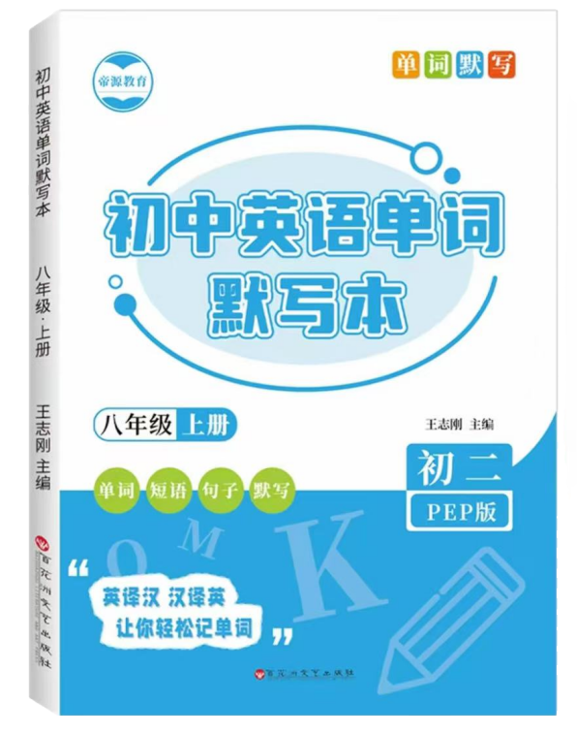

【译文】
一次特别的旅行
今年我度过了一个有意义的暑假。我的父母带我回到了乡下，我祖父母住在那里。我的祖父母有一个小花园，他们种了很多蔬菜和水果。我的父母和我帮助祖父母照料花园，并做农活。对我们来说，吃这些蔬菜很健康。同时，这里空气清新，交通不拥挤。住在这里的人们生活得很舒适。
总的来说，我真的很喜欢这里，在这里度过了愉快的时光。我希望明年暑假还能再来。

❤【写作练笔】
亲爱的同学们，今年暑假你们一定过得非常丰富多彩吧! 请你以“My Summer Holiday”为题，按照下面思维导图提示，写一篇文章在英语课上向同学们介绍一下你今年的暑假是如何度过的吧。
要求：
1. 所写内容应意思连贯、语法正确，书写工整；
2. 文中不得出现真实的人名和校名；
3. 100 词左右。
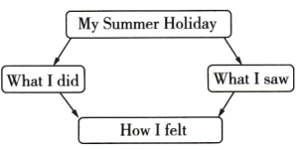

【范文】
My Summer Holiday
During the summer holiday, my family and l went to Guilin,
We arrived by train in the morning. Guilin is famous for its beautiful scenery. The Elephant Trunk Hil (象典山) and the LijiangRiver are must-sees, The water and mountains are as beautiful as a painting. We took a boat ride on the river, and it felt ike rowingin a picture. We took lots of photos there. n the evening, we just couldn't wait to try the local food-Guilin Rice Noodles. Theytasted very delicious.
As the saying goes, "Guilin scenery is the best in the world.”i really enjoyed this trip. And l look forward to visiting Guilinagain.
【译文】
我的暑假
暑假期间，我和家人去了桂林，
我们早上乘火车抵达。桂林以其美丽的风景而闻名。象鼻山和漓江是必游之地，山水如画，美不胜收。我们在漓江上泛舟，仿佛置身于画中。我们在那里拍了很多照片。晚上，我们迫不及待地想尝尝当地的美食——桂林米粉。它味道非常美味。
俗话说，“桂林山水甲天下”。我真的很喜欢这次旅行。我期待再次去桂林。

