五年级英语上册
《写人作文》范文汇总，学习背诵

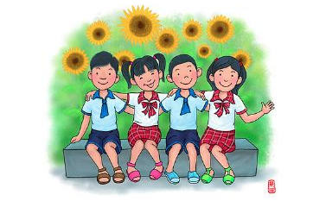

1.>>>My Best Friend<<<
我最好的朋友

I have many friends, but my best friend is Li Hua, she is a girl, we get to know each other when I am four.
我有很多朋友，但是我最好的朋友是李华，她是一个女孩，我们认识的时候我只有四岁。

Now I am ten years old, Li Hua is also the same age with me, we have been together for seven years.
现在我已经十岁了，李华也和我一样大，我们在一起已经有7年了。

We share happiness and sorrow, I will tell her my secret and she will also tell me her secret.
我们分享喜怒和哀乐，我会告诉她我的秘密，她也会告诉我她的秘密。

We will be best friends forever.
我们永远都是最好的朋友。

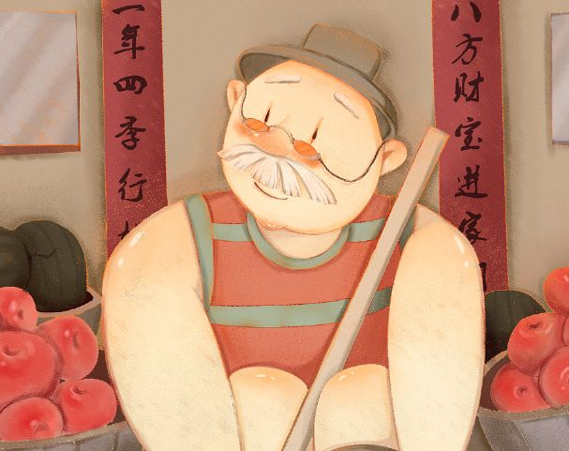

2.>>>My Grandfather<<<
我的祖父

My grandfather is quiet, when people ask him questions, he always answer them with few words.
我的祖父是一个安静的人，当人们问他问题的时候，他总是用几句话带过。

Though my grandfather is wordless, he loves me so much.
虽然我的祖父沉默寡言，但是他很爱我。

When I ask him to buy me the toys, he never hesitates, he will buy them for me.
当我叫他买玩具的时候，他从来不犹豫，他会买给我。

Every time when I think about it, I feel so moved, now winter holiday comes, I will go back to hometown and visit him.
每当我想起这个，我就会很感动，如今寒假到来了，我要会家乡看望祖父。

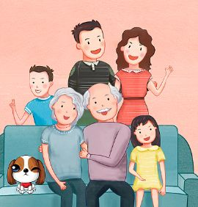

3.>>>My Family<<<
我的家庭

I have a happy family.
我有一个幸福的家庭。

There are three people in my family, my father, mother and me.
我家总共有3口人，爸爸，妈妈和我。

My father is a businessman.
我爸爸是一名商人。

He is always busy with his work and he often goes to business trips.
他总是忙于工作，而且他 经常出差。

But when he is free, he stays with us.
但是，只要他一有时间，他就陪我们。

My mother is a worker. She works hard, too.
我妈妈是一名工人,她工作也很努力。

She works hard to take care of our home.
她努力工作照顾我们这个家。

I love my parents.
我爱我的父母。

