五年级英语上册
《春节》范文素材汇总
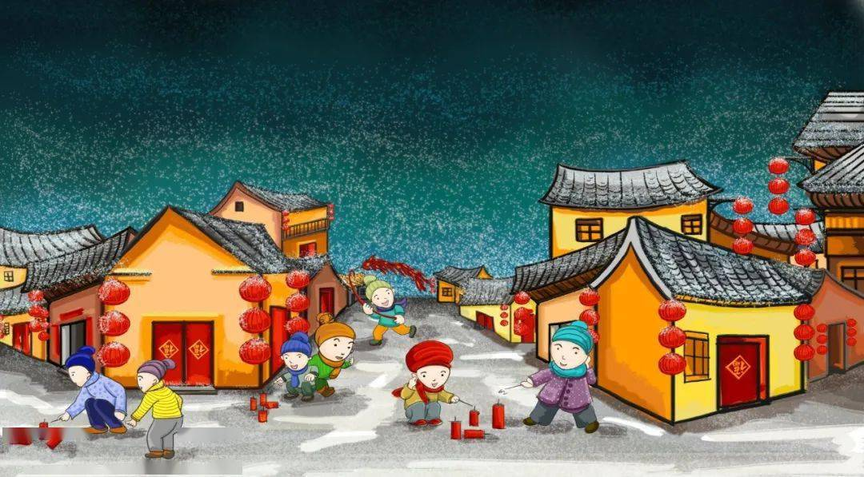
【小学关于春节的英语作文 篇一】

The Spring Festival is very important to Chinese people. In the past，people could not often have meat，rice or other delicious food. They could only eat these during the Spring festival. So every year they hoped that the Spring Festival would come soon. Now， although people‘s life is much better，and we can eat the delicious foods everyday. People still like the festival. Because most people can have a long holiday，and we are free to go on a trip or visit our friends or have parties with our family. In the evenings，we can have a big meal in the restaurant or stay at home with family and watch the TV programmes.
I like the Spring Festival very much. How wonderful the Spring Festival is!
春节是中国人民非常重要。在过去,人们不可能经常有肉,大米或其他美味的食物。在春节期间他们只能吃这些。所以每一年他们希望春节很快就会来的。现在,虽然人们的生活要好得多,我们可以每天吃美味的食物。人们仍然喜欢这个节日。因为大多数人可以有很长的假期,我们可以去旅行或访问我们的朋友和我们家有聚会。在晚上,我们可以有一顿大餐在餐馆或呆在家里和我的家人看电视节目。
我非常喜欢春节。春节是多么美妙!

【小学关于春节的英语作文 篇二】
The Spring Festival，Chinese New Year，is the most important festival for all of us. All family members get together on New Year'Eve to have a big meal.At the same time，everyone celebrates to each other.At about 12 o'clock，some parents and children light crackers.The whole sky is lighted brightly. We may watch the fireworks excitedly.How busy it is!
On the first early moring of one year， many senior citizen get up early and they stick the reversed Fu or hang some couplets on the front door. Some house\\'s windows are sticked on red paper cutlings.
The Chinese New Year lasts fifteen days. So during the fifteen days，we always visit our relatives from door to door. At that time， children are the happiest because they can get many red packets form their parents，grandparents， uncles， aunts and so on. The last day of the Chinese New Year is another festival. It names the Lantern Festival.
So the Chinese New Year comes to the end.
中国新年,春节是最重要的节日,我们所有的人。所有家庭成员聚在一起在新年吃一顿大餐。与此同时,每个人都互相庆祝。大约12点,一些家长和孩子们放鞭炮。整个天空是点燃明亮。我们可能会兴奋地观看烟花。多忙啊!
第一个一年的早期早上,许多老年人早起和他们把傅逆转或一些对联挂在前门。一些房子的窗户都在红纸上进发。
中国新年持续十五天。所以在十五天,我们总是访问我们的亲戚从门到门。那时,孩子是最幸福的,因为他们可以得到很多红包形成他们的父母、祖父母、叔叔、婶婶和等等。中国农历新年的最后一天是另一个节日。这名字元宵节。
所以中国新年结束。

