八下英语 | 单元话题写作
【unit5】写作指导&范文
【写作任务】
假如你所在中学的校刊近期开辟了英文专栏，征集发生在大家身边的感人故事。根据以下提示，为该专栏投稿。
要点提示：
1. 在一个寒冷的早晨，你买早餐时看到前面的女孩买了面包和牛奶。
2. 女孩要离开时，发现树下有一位老乞丐，他看上去又冷又饿。
3. 女孩走到乞丐身旁，把食物递给了他。
4. 乞丐向女孩道谢，女孩微笑着离开。
5. 你很感动……
参考词汇：
乞丐beggar；感动be moved

【谋篇布局】理清文章要素，构建文章结构。
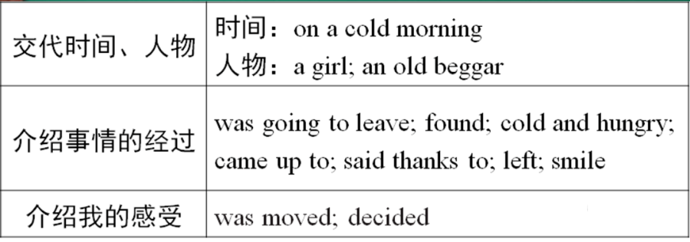

【遣词造句】就结构图中的要点和词语写出句子。
1. 当我正买早餐时，我看见在我前面的女孩买了一些面包和牛奶。
While I wasbuying breakfast, I saw a girl in front of mebuy some bread and milk.
2. 当那个女孩要离开时，她发现树下有一个老乞丐。
When the girl was going to leave, she found an old beggar under the tree.
3. 那个女孩走到他身旁，把她的早餐给了他。
The girl came up to him and gave her breakfast to him.
4. 当那个乞丐向女孩道谢时，女孩什么也没说并且微笑着走开了。
When the beggar said thanks to the girl , she said nothing and went away with a smile on her face.
5. 我被那个女孩所做的事感动了。
I was moved by what the girl did.

【巧妙衔接】利用连词，使句子意思连贯。
简述事情发生时用一般过去时和过去进行时，这两种时态的配合建立起上下文的逻辑联系。全文按照事情的发展过程来描述，运用连词when或while，使文章过渡自然。

【连句成篇】
On a cold morning, while I was.______
精彩范文：
On a cold morning, while I was buying breakfast, I saw a girl in front of me buy some bread and milk. When she was going to leave, she found an old beggar under the tree. He looked cold and hungry. The girl came up to him and gave her breakfast to him. When the beggar said thanks to the girl, she said nothing and went away with a smile on her face.I was moved by what the girl did. Her kindness touched me a lot. I decided to learn from her and be a kind person. I should help the people in need from now on.

【写作实践】
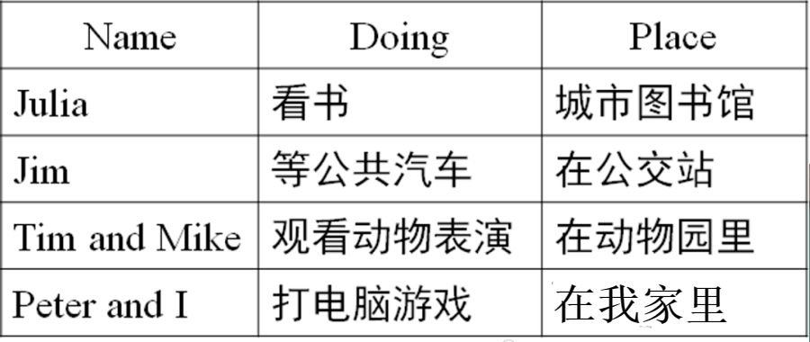
上个星期日下午三点，我市突然下起大暴雨，你的朋友们正在做着不同的事情。请你根据下面表格的内容，写一篇80词左右的短文。

范文：
A heavy rainstorm hit our city at 3：00 p. m. last Sunday. My friends in the city were doing different things at that time. Julia was reading in the city library. She could hear strong winds outside and the rain beat heavily against the windows. Jim was waiting for the bus at the bus stop. He didn't take an umbrella with him，so he was all wet. Tim and Mike were watching the animal shows in the zoo. Luckily, they found somewhere to get out of the rain. Peter and I were playing computer games in my home. However，because of the loud noise outside, we could hardly hear each other. Although we didn't care about it，we lost interest in the games. We didn't have fun with the rainstorm.

