七下英语 | 期末复习专练
【看图写话】训练
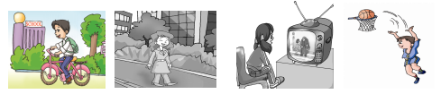
一、一般现在时
（主语 + 频度副词+ V原/Vs/es + 时间/地点）

1. often, home：He often goes home by bike.
2. usually, work：She usually goes to work on foot.
3. Lily, once a week ：Lily watches TV once a week.
4. often, after school He often plays basketball after school.

二、现在进行时
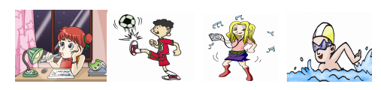
（主语 + be V-ing + 时间/地点）

1. Jane, now：Jane is doing She was born in 1973She was born in 1973homework now.
2. Look, now：Look, he is playing football.
3. she, music：She is listening to music.
4. he, now：He is swimming now.

三、一般过去式
（主语 + V过去式 + 时间/地点）
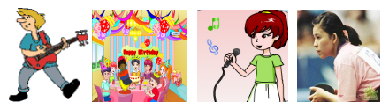

1. play, yesterday ：He played the guitar yesterday..
2. have, last night ：They had a birthday party last night.
3. Jane, sing, just now ：Jane sang a song just now.
4. born, in 1973 ：She was born in 1973.

四、There be句型
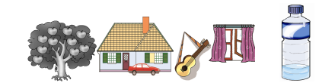
（There is/are + (a/an/some…) + 名词 + 介词 the 地点.）

1. there, apple ：There are many apples in the tree.
2. there, car：There is car in front of the houses.
3. there, guitar ：There is a guitar near the window.
4. there, football ：There is a football under the chair.
5. there, water ：There is some water in the bottle.
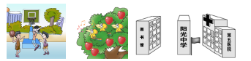
.

1. There be, boys, play：There are some boys playing basketball on the playground.
2. There be, bird, sing ：There are some bird singing in the tree.
3. school, between…and… ：The school is between the library and the hospital.

五、祈使句
（V原开头/ Don’t + V原）
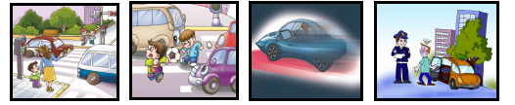

1. stop, red ：You should stop when the light is red.
2. not, play, on：Don’t play football on the street.
3. not, too fast ：Don’t drive too fast.
4. not, drink ：Don’t drive after drinking.

六．情态动词can/could
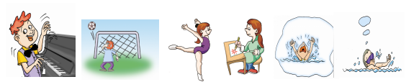
（主语 + V情 + V原）

1. can, very well：He can play the piano very well.
2. can not, last year：He can not play football last year.
3. can, and：She can dance and draw.
4. at the age of three, but, now：He could not swim at the age of three but now he can do it.
七、情态动词
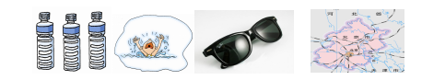
（should/had better）

1. should, more ：We should drink more water.
2. should not, alone：We should not swim alone.
3. had better, put on：You had batter put on the sunglasses.
4. had better, take, on your trip：You had better take a map on your trip.

八、不定式to do、天气
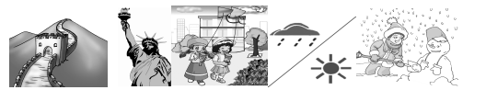
（It is/was + 形容天气的形容词 + 时间）、季节、气候

1. plan, visit ：He plans to visit the Great Wall.
2. hope, travel ：I hope to travel to the USA.
3. would like, tomorrow：Would you to fly kites tomorrow？.
4. it, today, but, yesterday ：It is sunny today but it was rainy yesterday.
5. good, time, winter ：Winter is a good time to make snowmen.

七下英语 | 期末复习专练
【看图写话】训练
一、一般现在时
（主语 + 频度副词+ V原/Vs/es + 时间/地点）

1. often, home：He often goes home by bike.
2. usually, work：She usually goes to work on foot.
3. Lily, once a week ：Lily watches TV once a week.
4. often, after school He often plays basketball after school.

二、现在进行时
（主语 + be V-ing + 时间/地点）

1. Jane, now：Jane is doing She was born in 1973She was born in 1973homework now.
2. Look, now：Look, he is playing football.
3. she, music：She is listening to music.
4. he, now：He is swimming now.

三、一般过去式
（主语 + V过去式 + 时间/地点）

1. play, yesterday ：He played the guitar yesterday..
2. have, last night ：They had a birthday party last night.
3. Jane, sing, just now ：Jane sang a song just now.
4. born, in 1973 ：She was born in 1973.

四、There be句型
（There is/are + (a/an/some…) + 名词 + 介词 the 地点.）

1. there, apple ：There are many apples in the tree.
2. there, car：There is car in front of the houses.
3. there, guitar ：There is a guitar near the window.
4. there, football ：There is a football under the chair.
5. there, water ：There is some water in the bottle.
.

1. There be, boys, play：There are some boys playing basketball on the playground.
2. There be, bird, sing ：There are some bird singing in the tree.
3. school, between…and… ：The school is between the library and the hospital.

五、祈使句
（V原开头/ Don’t + V原）

1. stop, red ：You should stop when the light is red.
2. not, play, on：Don’t play football on the street.
3. not, too fast ：Don’t drive too fast.
4. not, drink ：Don’t drive after drinking.

六．情态动词can/could
（主语 + V情 + V原）

1. can, very well：He can play the piano very well.
2. can not, last year：He can not play football last year.
3. can, and：She can dance and draw.
4. at the age of three, but, now：He could not swim at the age of three but now he can do it.
七、情态动词
（should/had better）

1. should, more ：We should drink more water.
2. should not, alone：We should not swim alone.
3. had better, put on：You had batter put on the sunglasses.
4. had better, take, on your trip：You had better take a map on your trip.

八、不定式to do、天气
（It is/was + 形容天气的形容词 + 时间）、季节、气候

1. plan, visit ：He plans to visit the Great Wall.
2. hope, travel ：I hope to travel to the USA.
3. would like, tomorrow：Would you to fly kites tomorrow？.
4. it, today, but, yesterday ：It is sunny today but it was rainy yesterday.
5. good, time, winter ：Winter is a good time to make snowmen.

