2024--2025学年七年级第一学期期中达标检测卷
【英语】
第Ⅰ卷 听力部分
Ⅰ.听句子, 从 A、B、C 三个选项中选出与所听句子相对应的图片。每个句子读两遍.

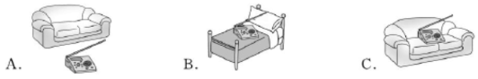
1.


2.
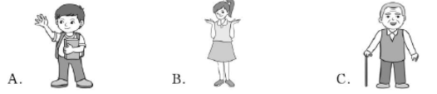

3.
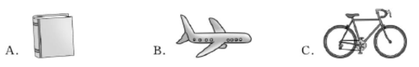

4.
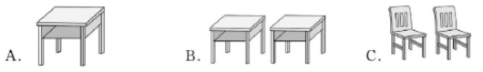

5.

Ⅱ.听对话, 选择正确答案。每段对话读两遍
6.Who is Mary’s friend?
A.Eric. B.Bob. C.Gina.
7.What’s Alan’s family name?
A.Brown. B.Miller. C.Smith.
8.Can the man spell “key”?
A.Yes, he can. B.No, he can’t. C.Yes, she can.
9.Where is Linda’s ruler?
A.In her desk. B.In her schoolbag. C.In her pencil case.
10.Are they her books?
A.Yes, they are. B.No, they aren’t. C.Yes, they aren’t.

Ⅲ.听短文, 根据短文内容填空。每空填一词, 短文读两遍
Our classroom
Things | Five 11. and the pencil box are on a desk.  Two pencils and one 12. are in the pencil box.  A schoolbag is 13. the desk.
People | Lily is seven and David is 14. .
Inference(推断) | The classroom can hold(容纳) 15. . students.

第Ⅱ卷 笔试部分

Ⅳ.完形填空
Dave comes from England. But now, he 16 .to Shanghai No.1 Middle School every day. He is a new 17 .there. There are fifty students in his class, 18 .boys and twenty girls. Jim and Rick are his 19 . Jim is a(n) 20 .boy, too. But Rick is from Canada. They are in the same class. They all like China very much.
There are many things like 21 .and chairs in their classroom. And there is a whiteboard in the front of the 22 . Next to the classroom building is the library. There are lots of 23 .in it. Dave likes reading books there in the afternoon. Behind the library is the sports hall. Peter often 24 .basketball with his friends after school. The building near the sports hall is for 25 .There are four science labs in it.
16.A.goes B.writes C.listens D.puts
17.A.actor B.driver C.student D.teacher
18.A.fifty B.thirty C.twenty D.forty
19.A.brothers B.friends C.teachers D.parents
20.A.good B.nice C.English D.American
21.A.bikes B.trees C.cats D.desks
22.A.shop B.playground C.classroom D.bus
23.A.toys B.boxes C.books D.pianos
24.A.plays B.opens C.helps D.knows
25.A.lunch B.sports C.science D.girls

Ⅴ.阅读理解
Dear Diana,
Let me tell you about my family. I live with my mum, my dad and my sister. We live in New York. My mum’s name is Carmen. She’s Mexican(墨西哥的) and she speaks English and Spanish(西班牙语). She’s a Spanish teacher.She’s short and slim(苗条的). She has long brown hair and brown eyes. My dad’s name is David. He’s American. He’s tall and a little fat! He has short brown hair and blue eyes. He works in a bank which is far from our house. My sister Shania is 14 years old and she loves listening to music. She listens to music all the time! She has long brown hair and blue eyes. I have long hair too.We have a pet dog. It’s black and white. It’s very friendly.
Write soon and tell me about your family.
Love,
Kelly

26.How many people are there in Kelly’s family?
A.Two. B.Three. C.Four. D.Six.
27.Kelly’s mother, Carmen, is .
A.Spanish B.Mexican C.American D.Australian
28.What colour are David’s eyes?
A.Brown. B.Blue. C.Black. D.Green.
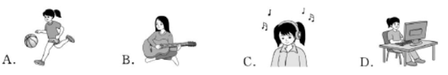
29.What does Shania like doing?

30.The letter mainly tells us about .
A.Diana’s school B.Diana’s family
C.Kelly’s job D.Kelly’s family

Ⅵ.语法填空
Hello, I’m Grace. Let me 31. (tell) you something about my school. It is beautiful and quiet. Our school is next to a new building 32. Green Street. There 33. (be) a clean and big sports field across from the teachers’ 34. (build). I often play football with my classmates. There 35. (be) two music halls in my school. I go there to learn 36. (play) the piano every Saturday afternoon. It’s across from an art building. Is there a science building in my school? Of course, there is. It’s 37. the library and the computer building. We often do physics experiments(实验) there. 38. (I) favourite place in my school is the library. It’s next 39. the music hall. It’s across from an old teachers’ office. My classmates often 40. (read) in the library.
I love my school very much. What about your school?

Ⅶ.书面表达
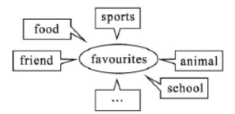
假如你是杨慧(Yang Hui), 你的笔友大卫(David)想了解你的兴趣和生活喜好、学校等, 请你根据图片, 给他回一封邮件。

要求:
1.邮件应至少从5个方面进行介绍, 并简单说明理由, 可适当发 挥;
2.不少于 70 词; 开头和结尾已给出, 不计入总词数。
Dear David,
I’m happy to get your letter. Let me tell you something about my favourites.
________________________________________________________________________________________________________________________________________________________________________________________________________________________________________________________________________________________________________________________________________________________________________________________________________________________________________________________________________________________________________________
What about you? Please write to me soon.
Yours,
Yang Hui
【听力原文】
Ⅰ.
1.The radio is on the sofa.
2.Miss White says “Good morning!” to her parrot every morning. 3.That old man is my grandfather.
4.Jim likes his bike a lot.
5.There are two desks in that classroom.
Ⅱ.
6.M: Is Gina your friend, Mary?
W: Yes, she is my good friend.
7.M: Hello! Are you Lucy?
W: Yes, I am.
M: I am Alan Smith. Nice to meet you!
W: Nice to meet you too.
8.W: What’s this in English?
M: It is a key.
W: Can you spell it?
M: Yes. K-E-Y.
9.M: Is your ruler in your pencil case, Linda?
W: No, it isn’t. Oh, it’s in my schoolbag. Here you are.
M: Thank you.
10.M: Are these your books?
W: No, they aren’t. They’re my brother’s.
Ⅲ.
My name is Bob and I’m nine years old. This is our classroom.
Look! What’s in the classroom? We have nine desks and eight chairs. Five books are on a desk. Two pencils and one eraser are in the pencil box. Where is the pencil box? It’s on the desk. Look! That’s a schoolbag. It’s under the desk. A baseball is under the chair, on the floor.
A girl and a boy are in the classroom. The girl is Lily. She is seven. The boy is David. He is nine. They are my friends. Our teacher is John. He is in the classroom, too.

【答案】
Ⅰ.
1—5 CBCCB
Ⅱ.
6—10 CCABB
Ⅲ.
11.books 12.eraser 13.under 14.nine 15.eight
Ⅳ.
16—20 ACBBC 21—25 DCCAC
Ⅴ.
26—30 CBBCD
Ⅵ.
31.tell 32.on/in 33.is 34.building 35.are 36.to play 37.between 38.My 39.to 40.read
Ⅶ.
Dear David,
I’m happy to get your letter. Let me tell you something about my
favourites. My favourite food is fruit, such as apples and bananas. I think they are good for my health. I like doing sports and I like swimming best. Because it is fun and interesting. The horse is my favourite animal. Because it is beautiful. My best friend is Amy, and we are in the same class. My school is beautiful and big, and you can see many beautiful flowers and trees around it. I like running every morning.
What about you? Please write to me soon.
Yours,
Yang Hui

