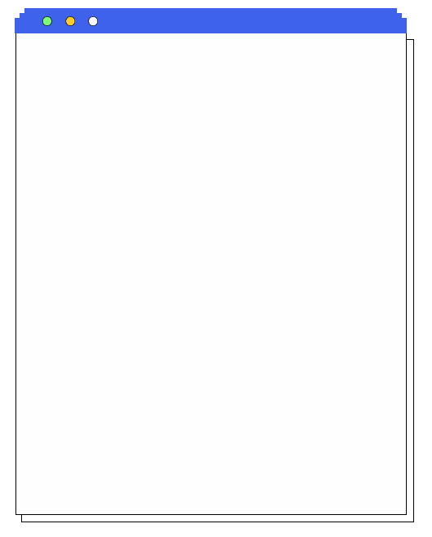
2024人教版 | 九上英语期末复习专练
【完形填空】过关练习（三）

“What year were you born, Grandma?” Patrick asked.Patrick was in the ninth grade and his homework was to 1 someone born before 1950 to see what their childhood was like. He had chosen to talk to 2 Grandma.
“I was born in 1943, during World War Two,” Patrick’s Grandma answered.
“Did you go 3 ?” Patrick asked.
“Yes, I went to school in Mayville,” Grandma said.
“What did you do after school, Grandma?” Patrick asked. “Did you watch TV or play 4 ?”
Patrick’s Grandma laughed, “Of course not. We didn’t 5 video games back then. My family didn’t even get a TV 6 I was twelve.”
“No TV?” Patrick asked.
Grandma smiled and said, “Those were the 7 old days.”
Patrick tried to imagine what life would be like without TV, video games and computers. He wondered 8 grandma called her past “the good old days.”
Patrick looked confused (困惑的), and he asked, “What did you do for fun?”
“Well, I read books. After dinner and homework, sometimes we would 9 the radio while we played card games.”
“Grandma, did you have ice cream when you were a 10 ?” he asked.
“Yes, of course we did”, Grandma answered.
（B）1. A. admire B. interview C. create D. treat
（D）2. A. your B. my C. her D. his
（C）3. A. home B. to the hospital C. to school D. to the office
（C）4. A. the violin B. basketball C. video games D. chess
（A）5. A. have B. use C. choose D. give
（B）6. A. since B. until C. unless D. after
（C）7. A. long B. short C. good D. bad
（A）8. A. why B. how C. where D. if
（C）9. A. hear B. see C. listen to D. look at
（D）10. A. doctor B. teacher C. boy D. girl
2024人教版 | 九上英语期末复习专练
【完形填空】过关练习（三）

Have you learned about table manners in China？Here I will introduce some.
It is a traditional __1__ for Chinese people to eat with chopsticks. Each person at table will have a pair of chopsticks，and there is also an extra pair __2__ is for public use.
You should remember that you're __3__ to let the elders in the family sit and eat first. If they don't start，everyone else shouldn't start，either. And then you should make a __4__ to them.
While eating，it is very rude to eat with a loud __5__．And you'd better not speak while food is still in your __6__．Do not only eat one dish even if that is your favorite.
People usually go out of their way to cook delicious food to make you __7__ at home，but when they say，“The dishes aren't delicious. I __8__ you don't mind，”you must not say，“Yeah，that's true，but I don't mind.”__9__，it is a typical (典型的) word which can show one of the Chinese qualities—__10__．You should answer，“Really？I don't think so. It is the best taste of any dish that is new to me.”
（D）1.A.point B．order C．method D．custom
（A）2.A.which B．who C．where D．when
（C）3.A.allowed B．considered C．supposed D．invited
（D）4.A.report B．research C．bow D．toast
（C）5.A.voice B．smile C．noise D．cry
（B）6.A.plate B．mouth C．hand D．bowl
（A）7.A.feel B．arrive C．eat D．aim
（D）8.A.realize B．suggest C．expect D．hope
（B）9.A.However B．Actually C．Instead D．Finally
（C）10.A.honest B．proud C．modest D．serious
2024人教版 | 九上英语期末复习专练
【完形填空】过关练习（三）

Some students cheat（作弊）because they're busy or lazy and they want to get good grades without 1 the time studying. Other students might feel that they can't 2 the test without cheating. Even when there seems to be a “good reason” for cheating, it isn't a good idea.
A student who thinks cheating is the only way to pass a test 3 to talk with the teacher and his or her parents so they can find some better ways together. Talking about these problems and 4 them out will help feel better than cheating.
If a student gets caught cheating, the teacher may give a “zero” on the test, send him or her to the head teacher's 5 , and call his or her parents. Worse than the 6 grade may be the feeling of having disappointed those people, like parents and teachers. A parent may worry that you are not an 7 person and a teacher might watch you more closely the next time you're taking a test.
There are plenty of reasons why a kid shouldn't cheat, but some students have already cheated. If that's you, it's 8 too late to stop cheating. Cheating can become a 9 , but a student is always able to act better and make better 10 . It might help to talk the problem over with a parent, teacher, or friend.
（B）1. A. taking B. spending C. costing D. using
（C）2. A. write B. exercise C. pass D. expect
（D）3. A. decides B. hopes C. refuses D. needs
（D）4. A. breaking B. dreaming C. missing D. working
（A）5. A. office B. school C. seat D. conversation
（D）6. A. natural B. dangerous C. anxious D. bad
（D）7. A. outside B. boring C. interesting D. honest
（B）8. A. always B. never C. once D. neither
（C）9. A. menu B. medicine C. habit D. match
（B）10. A. education B. decisions C. challenges D. risks
2024人教版 | 九上英语期末复习专练
【完形填空】过关练习（三）

When he was 12 years old, the boy did something he only later realized probably hurt his teacher. He was, after all, a(n) 1 at that time. When he was older and wiser, he wanted to 2 this teacher and say sorry. 3 the teacher seemed to have disappeared.
He never 4 searching. Last month — by now nearly 42 years after the event happened — 5 succeeded.
Excited, he started 6 a news report I had written in a magazine about a program that helps kids. He studied a photo and found his teacher, who was a volunteer. He then emailed me and 7 me to introduce him to the teacher, James Atteberry.
I got in touch with Atteberry. He agreed to talk to his student. Soon, I received a letter. I immediately 8 it to Atteberry.
In the letter, Larry said, “I am truly 9 for leaving your Seventh Grade class during the 1972-1973 school year. I don’t have many memories from school, but at the top of my exercise book you wrote ‘You will go far in life.’ 10 my school life, I was proud to be your student.”
When it comes to apologies, no one gets a pass. Everyone needs to receive one, and everyone needs to give one.
（A）1. A. kid B. teacher C. old man D. famous person
（C）2. A. refuse B. believe C. find D. leave
（B）3. A. Since B. But C. Because D. So
（A）4. A. stopped B. started C. continued D. remembered
（D）5. A. you B. they C. she D. he
（B）6. A. separating B. reading C. creating D. announced
（C）7. A. listened B. looked C. asked D. helped
（C）8. A. wrote B. lent C. sent D. borrowed
（A）9. A. sorry B. happy C. proud D. excited
（B）10. A. Looking forward to B. Looking back at
C. Talking back to D. Catching up with

2024人教版 | 九上英语期末复习专练
【完形填空】过关练习（三）

There was once a grey planet (行星). The people living there didn’t take care of it. The planet was full of 1 . It was so dirty that there were no plants or animals left.
One day, a 2 was walking on the planet. When he passed a cave (洞穴), he noticed a small red flower inside. The flower was dying (垂死的), so the boy carefully dug it up. Then, he started looking for a place where he could 3 it. He searched all over the planet, but the planet was so 4 that there was no place to plant the flower.
Suddenly, he thought maybe the flower could be planted on the 5 . So he went to the moon and then planted the flower there.
Far away from pollution, the flower 6 to grow. The flower was so 7 cared for that it soon produced other flowers. Before long, the whole moon was completely covered with 8 . They were quite beautiful.
That’s 9 , whenever the boy’s flowers bloom (开花), the moon has a red sheen (光辉). It looks like a warning light. It tells us that 10 you don’t look after your planet, a day when flowers will only be able to grow on the moon will come.
（D）1. A. water B. space C. food D. litter
（C）2. A. girl B. woman C. boy D. man
（B）3. A. throw B. plant C. sell D. catch
（A）4. A. polluted B. large C. quiet D. clean
（D）5. A. park B. garden C. sun D. moon
（C）6. A. remembered B. forgot C. started D. stopped
（A）7. A. well B. badly C. clearly D. slowly
（B）8. A. trees B. flowers C. clouds D. people
（D）9. A. what B. who C. where D. why
（C）10. A. although B. unless C. if D. so

