七年级英语上册 | 期末复习强化训练
【书面表达】押题范文6篇
【一】寒假即将到来，你的美国网友Tim发 email告诉你，他将要来中国过春节．这是他第一次来广州，请你结合下面概念图中的要点回复邮件给他，简单介绍广州及广州的春节习俗．
注意：
1）词数70个左右（信的开头已给出，不计入词数，但要根据要点适当发挥）；
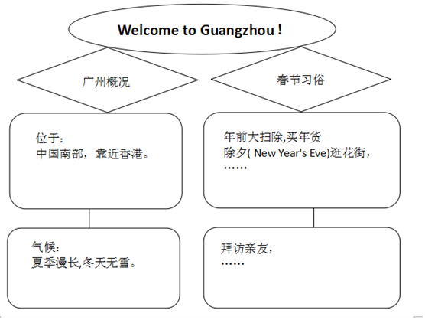
2）不得透漏学校、姓名等任何个人信息，否则不予评分．

[来源:学科网ZXXK]

Dear Tim，
Glad to know you will visit Guangzhou during the Spring Festival．I'm happy to tell you something about Guangzhou and the customs （习俗） of the Spring Festival here．
Guangzhou lies in the south of China and near Hong Kong．Summer is very long.There is no snow in the long winter．We alwaysdo some cleaning and buy New Year's goods before new year．We hang out on the flower street on New Year's Eve．On the firstday of new year，we visit our friends and relatives and say happy new year each other．To help you get used to the life in Guangzhou，I will show you around the places of interest in Guangzhou．And you can take a plan and do what you want to do in Guangzhou．
Yours，
Li Hua．
【二】假如你是Linda．在寒假即将到来之际，你结交了一位美国新朋友Sally．请你给她写一封信详细介绍下你自己吧．可适当发挥．60词左右．开头已给出，不计入总词数．
Dear Sally，
I am happy to be your new friend．Let me introduce myself first．
My name is Linda Brown．Linda is my first name and Brown is my last name．My birthday is on June 10th，My father is JimBrown and my mother is Marry Brown．I like vegetables and fruits best．They are delicious．I like English and science bestat school．What can I do？I can play basketball．I usually get up at 6：00 and eat lunch at 12：00．I go to bed at 21：00.
Linda

【三】假如Peter是你的笔友，请根据下列表格所提供的信息, 写一篇短文介绍一下他的情况。
Name | Peter
From | America
Age | thirteen years old
Looks | head: big hair: blond eyes: small, blue
Clothes | a white T-shirt, blue pants
Favorite | color: blue food: hamburgers animals: lions
Family | father (an office worker), mother (a nurse)
Timetable | get up: 6:40 a.m.  go to school: 7:15 a.m.  have dinner: 6:30 p.m.
要求：
1.语义通顺，句子连贯，书写工整。
2.表格信息要全部用上，可适当拓展。
3.词数：70词左右，开头已给出，不计入总词数。
Peter is my pen pal. He is a student.He is 13 years old. He comes from America. He is short with blond hair and small blue eyes. He has a big head. His favorite color is blue. He is usually in blue pants and a white T-shirt. He usually gets up at 6:40a.m.. At 7:15a.m., he goes to school. He has a happy family. His father is an office worker. His mother is a nurse. He usually has dinner with his parents at 6:30 p.m.His favorite animals are lions and favorite food is hamburgers.

【四】根据中英文提示，写一篇意思连贯、符合逻辑、不少于40词的短文．请不要出现真实的学校、班级和姓名．
学校正在举办英语征文大赛，请你以"My Good Friend"为题写一篇征文，介绍你想介绍的一位朋友．内容包括他/她的基本信息、外貌、爱好等．
提示词语：
years old，tall，like doing，help
提示要点：
Who is he/she？
What does he/she look like？
What does he/she like？
My Good Friend
My good friend is a beautiful girl called Song Min，who is 15 years old now．She looks very tall and slim，and she has long black hair．She loves reading，and every Friday afternoon is her time for a reading club．What's more，she likes singing．She listens to the music at weekends，too．Yu Wenhua is her favorite singer．She is polite，and helpful．She is friendly to our teachers and classmates．She often helps her parents with housework．This is my good friend，everyone likes her very much．What about you？

【五】假如你经营一个名为Mary’s Clothes Store的服装店，最近你店里在做促销活动。请你根据下面给出的信息，用英语写一则促销广告。
Things | Colors | Price
coats (外套) | many colors | 80 yuan
trousers | brown; black | 50 yuan
skirts | green; yellow | 45 yuan
要求:
1.语言流畅、书写规范、卷面整洁，词数不少于50个；
2.文中不得使用真实姓名、校名，否则以零分计；
3. 将短文写在答题卷上，写在本卷上无效。
Mary’s Clothes Store
Come and buy your clothes at Mary’s Clothes Store, They are on sale now, We have coats in different colors and we sell only 80 yuan for one. And we have trousers in brown and black. They’re at a very good price- only 50 yuan for one pair. For girls, we have green and yellow skirts for 45 yuan. Come to our store now.

【六】假设David是你新结识的笔友(new pen pal)。下表是他的相关信息。请你根据此表中的信息向你的同学介绍他。要求不少于50词。
Name | David
Age | 13
Date of birth | September 5th
Favorite sports | tennis，pingpong and soccer
Favorite food | fruit and vegetables
Favorite subjects | English and math
David is my new pen pal.He is 13.His birthday is on September 5th.He likes sports very much.He likes playing tennis，pingpong and soccer best，and he often plays with his friends.David likes eating healthy food.He eats lots of fruit and vegetables every day.His favorite subjects are English and math.He is a good boy.

