2024~2025学年七年级第一学期期末检测培优卷
……○…………外…………○…………装…………○…………订…………○…………线…………○…………

【英语】
姓名： 班级： 考号： .
题号 | 一 | 二 | 三 | 四 | 五 | 总分
评分
笔试部分
二、单项填空（共15小题，计15分）
21. 下列单词中划线部分的读音不同于其他三项的一项是
A．sell B. help C. twelve D. be
22. ---Here _________ some books for you，Tom.
---Thanks a lot.
A. is B. are C. am D. be
23. ---Is this your notebook?
---No，it isn’t. Ask Jane. She is looking for __________.
A. your B. yours C. her D. hers
24. I think math is _________. I like it very much.
A. interesting B. boring C. small D. big
25. I like bananas，but Linda doesn’t like_________.
A. it B. them C. they D. these
26. ---I want to see the movie The Penguins of Madagascar (《马达加斯加的企鹅》). Do you know the _________ of the ticket（票）?
---Yes. Five dollars.
A. number B. price C. kind D. name
27. Friday is __________ birthday of my grandma’s.
A. eighty B. the eightieth C. eightiethD. the eighty
28．_____ black shoes are $26.
A. That B. This C. It D. These
29. They have ________ art lesson ________ 9:00.
A. a，at B. a，in C. an，at D. an，in
30. He wants ______ a pair of white shoes. Let’s go shopping together.
A. buy B. sell C. to buy D. to sell
31. ---Do you have yellow skirts in your store?
--No，but we have skirts ________ purple and pink.
A. for B. in C. at D. with
32. There are ______ months in a year. The __________ month is September.
A. twelfth，ninth B. twelve，nine C. twelfth，nine D. twelve，ninth
33. --- How old _______ your cousin?
---He is fourteen _______ old.
A. Is，year B. is，years C. are，years D. are，year
34.---________ are the trousers?
---Oh，the black trousers? They are only ten dollars.
A. What color B. How much C. How many D. Where
35. --Thank you for your help.
--___________________.
A. No，thanks B. You’re welcome C. That’s right D. All right.

三、完形填空（共10小题，计10分）
Dear Tom,
My name is Liu Yun. I’m a 12-year-old girl. I’m the only 36 in my family. My birthday is on 37 1st. It’s the 38 day of the tenth month. It’s also the National Day. My parents 39 a party for me on that day. My friends 40 to the party. They bring(带来) me some birthday presents(礼物)，and they sing(唱) Happy Birthday to me. 41 eat some fruit: strawberries，oranges and 42. We eat chicken and apples 43 dinner. We also play games. We have a 44 time!
What’s your age(年龄)? 45 is your birthday? Can you let me know?
Yours,
Liu Yun
( )36. A. son B. daughter C. boy D. people
( )37. A. April B. September C. October D. December
( )38. A. first B. second C. fourth D. tenth
( )39. A. look B. have C. call D. sell
( )40. A. come B. take C. find D. help
( )41. A. You B. We C. They D. I
( )42. A. carrots B. bananas C. tomatoes D. chicken
( )43. A. on B. in C. for D. of
( )44. A. difficult B. boring C. healthy D. good
( )45. A. What B. How C. When D. How old
四、阅读理解（共10小题，每小题2分，计20分）
根据短文内容，选择最佳答案。
(A)
Rick is a good man. He makes birthday cakes in a store. His cakes are great and have very good prices，so many people buy his cakes. He makes friends with lots of his customers(顾客). They all like him very much. One evening，he wants to go home，but many of his old customers come in. Rick smiles(笑) to them，“I am sorry. It is late today. If you need cakes，please come tomorrow（明天）.” One of them takes out （拿出）a nice cake and says to him，“You make so many great cakes for us. This birthday cake is for you. Happy birthday，Rick.”
46. Where does Rick work?
A. At school B. In the classroom C. In a store D. At a party.
47. When the customers come，Rick _______________.
A. is making cake B. is at home
C. wants to go home D. is playing basketball
48. His customers give(给) him ___________.
A. many cakes B. a birthday cake C. some vegetables D. some fruit
49. Rick’s customers like him because __________________.
A. he is a good man B. his cakes are big
C. his cakes are at a very good price D. A and C
50. The customers come to Rick’s store because ______________.
A. they want to buy cakes B. today is Rick’s birthday
C. Rick asks them to come D. they come for a party
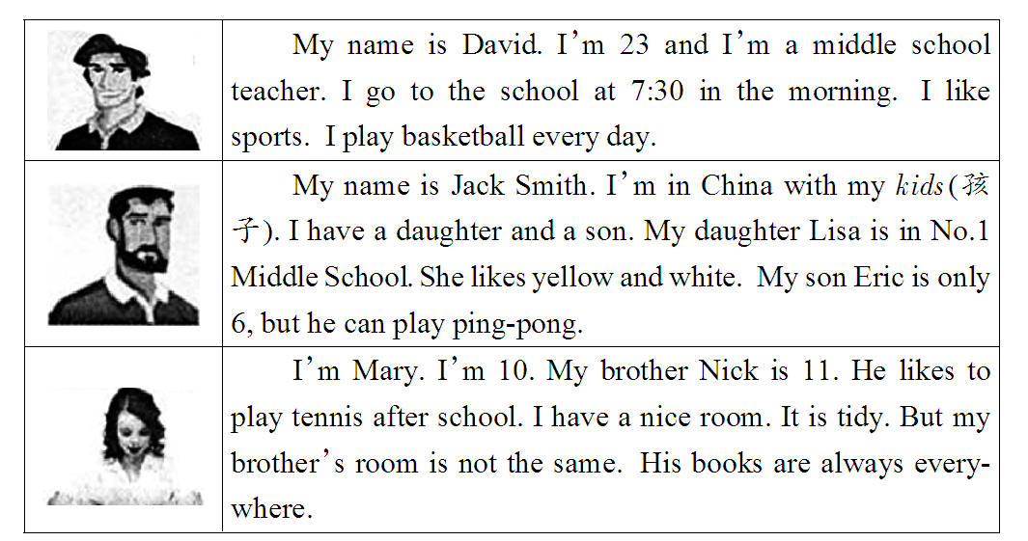
(B)

51. What sport does David play every day?
A. Soccer. B. Ping-pong．
C. Volleyball. D. Basketball.
52. Who likes to play tennis after school?
A. Mary. B. Eric. C. Nick. D. Lisa.
53. What color does Lisa like?
A. Yellow and white. B. Yellow and blue.
C. Green and white. D. Yellow and brown.
54．room is tidy.
A. David’s B. Jack’s C. Mary’s D. Nick’s
55. Which of the following is TRUE(正确的)?
A. Mary’s books are everywhere.
B. David，Jack and Mary are all in China now.
C. Lisa is in No.1 Middle School.
D. Eric goes to school at 7:30 with her sister.

五、划掉括号里的错词， 使句子意思正确。（共5小题，每小题1分；计分5分）
56. She sings very well but she can't (dance；dances).
57. The (nine；ninth) month of the year is September.
58. The socks are on (sell；sale) for only seventy dollars.
59. For dinner，Tom likes chicken and (tomato；tomatoes)
60. I want him to help (me；I )

六、任务型阅读(满分5分)
根据短文后所给的任务，完成61-65小题。（本题共5小题，每小题1分，计5分）
My name is Lucy. ①10th today October is. It’s my birthday. I’m thirteen. My cousins，Xiao Ming and Li Chuan，are in my home. My parents buy me a big A cake(蛋糕). It’s on the table. You can see some birthday candles(蜡烛) B the cake. My cousins buy some fruit and school things for me. ②I’m very happy today.
任务一: 请在文中A、B 两处的横线上填入适当的单词。(每空一词)
61. A.________________；B.________________；
任务二: 请将文中①处后面的斜体单词连成句子。
62.________________________________________________________；
任务三: 请将文中②处划线句子翻译成汉语。
63.________________________________________________________；
任务四: 请回答问题： How old is Lucy?
64.________________________________________________________；
任务五: 请给短文拟一个适当的标题。（10词以内）
65.________________________________________________________；

七、句型转换(每空一词，缩写算一个词)（共5小题，计5分）
66. My brother wants to join the music club. (改为一般疑问句）
_____ your brother want to join the music club?
67. My mum’s birthday is on 7th October. (对划线部分提问)
______ is your mum’s birthday?
68. It is her new sweater. (改为复数句）
______ their new sweaters.
69. Do you know Mary is from America? (否定回答）
No，I ______.
70. How much are these yellow socks? (改同义句）
How much is this ______ of yellow socks?

八、词语填空（共10小题，计10分）
用方框中所给单词的适当形式填空，使短文完整、通顺。每词限用一次。（本题共10小题，每小题1分，计10分）
much， when， happy， he， brother， six， too， December， she， parent
I have a big family. There are (71)________people in my family. They are my grandparents，my (72) ________，my brother and me. My grandfather likes hamburgers. (73)________birthday is on January 15th. My grandmother likes hamburgers，(74) ________ . Her birthday is on June 28th. My father’s birthday is on (75)________26th. My mother likes vegetables. (76)________birthday is on February 9th. My birthday is on June 9th. Today is my (77)________birthday. It’s on February 21st. Look! A birthday cake is on the table. How (78)
________is it? It’s 20 dollars. It’s his seventh birthday. We are all very (79)________today. (80)________is your birthday?

九、书面表达（计10分）
下学期，你的表弟Max将要作为交换生到你们班级学习一年，班主任请你在班会课上介绍一下Max的情况，以便让同学们更快地了解他。请根据下列提示，写一篇 90 词左右的文章。
要求：1. 文章必须包含表格中所有信息，并作适当发挥;
2. 文中不得出现真实的人名;
3. 词数90词左右，文章的开头和结尾已经写好，不计入总词数。
基本情况 | Max，  13岁，  来自加拿大；  个子高、戴眼镜，  喜欢穿T恤、牛仔裤和运动鞋；
品性事迹 | 友善，从不捉弄别人；  ……（自拟一点）；
兴趣爱好 | 打篮球以保持健康；  ……（自拟一点）；
愿望 | 对中国的春节感兴趣，想要……  （自拟两点）

Hello，everyone. My cousin Max will come to our class as an exchange student. Now I would like to tell you something about him. _____________________________ That’s all. Thanks for listening.

参考答案
1-5 BABCB 6-10 BCCAC 11-15 CCABA 16-20 CAABC
21-25 DBDAB 26-30 BBDCC 31-35BDBBB 36-40 BCABA
41-45 BBCDC 46-50 CCBDB 51-55DCACC
56. （dances）
57. (nine)
58. (sell)
59. (tomato)
60. (I)
61. A. birthday B. on
62. Today is October 10th.
63. 我今天非常开心。
64. She is thirteen.
65. Lucy’s/My birthday
66. Does
67.When
68.They’re
69. don’t
70.pair
71. six 72. parents 73. His 74. too 75. December
76. Her 77. brother’s 78. much 79. happy
80. When
九、范文
Hello, everyone. My cousin Max will come to our class as an exchange student. Now I would like to tell you something about him. Max is13 years old, from Canada.He is tall and wears glasses. He likes to wear T-shirts, jeans and sports shoes.He is very friendly and neverplays tricks on others .He lilkes playing basketball to keep fit.He thinks doing exercise is good for health.He is interested in Chinese SpringFestival and wants to spend it with us.

