2025学年中考模拟百校联考综合测评卷
【英语】
（考试时间120分钟 满分120分）
卷Ⅰ（共三部分，满分70分）
第一部分 听力（共两节，满分20分）略
第二部分 基础知识运用（满分15分）
完形填空（共两篇，共15小题，每小题1分，满分15分）
A
Dear Mother Earth,
Thank you for giving me a home. There’s no other planet like you! Your soil (土壤) ____1____ me grow and eat fruit and vegetables. Your air lets me breathe. Your water lets me play and swim in it, especially in hot summer. Your wood allows me to have a warm fire when it is cold. I’m sorry ____2____ your forests are getting smaller and smaller.
I promise I will do my best to protect you. I will produce less ____3____ by using more cloth bags and china cups. I will reuse paper so many of your trees won’t get cut down! I’ll try to recycle everything I can, like plastic and newspapers, so they can be made ____4____ some toys and other useful things. I hope none of the animals get hurt or killed. I’ll keep my ____5____.
Happy Your Day!
Love,
Your child
（ D ）1. A. asks B. tells C. allows D. lets
（ B ）2. A. what B. that C. which D. where
（ A ）3. A. waste B. power C. energy D. water
（ B ）4. A. in B. into C. of D. from
（ C ）5. A. problem B. present C. promise D. place
B
There is a small thing we use every day. We usually put ____6____ in the bathroom. If we don’t use it, we might have tooth problems. Can you guess what it is? Yes, it’s the toothbrush. But do you know ____7____ about its history?
Before toothbrushes appeared, the ancient Chinese people ____8____ their teeth with some small tree branches (树枝). About 800 years ago, people ____9____ a kind of toothbrushes with pig hair and bamboo. It might be the world’s earliest form of toothbrushes. As time went by, the form of toothbrushes ____10____. For example, people didn’t use pig hair to make toothbrushes ____11____ it was too hard (硬的). They began to use horse-tail hair which was much softer. Imagine that you travel back to hundreds of years ago and brush your teeth ____12____. It sounds fantastic, doesn’t it?
Around the 15th century, the Chinese toothbrush found its way into Europe. It became ____13____ among local people soon. The ____14____ of toothbrushes was not as famous as that of paper-making, but it was very useful in daily life. Today we get into the good ____15____ of brushing teeth. We should thank the ancient Chinese for it.
（ C ）6. A. them B. they C. it D. its
（ B ）7. A. something B. anything C. somewhere D. anywhere
（ A ）8. A. cleaned B. broke C. took D. protected
（ C ）9. A. did B. repaired C. made D. showed
（ D ）10. A. appeared B. touched C. discovered D. changed
（ A ）11. A. because B. so C. or D. but
（ C ）12. A. angrily B. hardly C. comfortably D. badly
（ A ）13 A. popular B. different C. strange D. boring
（ D ）14. A. action B. pollution C. tradition D. invention
（ B ）15. A. task B. habit C. result D. fact

第三部分 阅读理解和口语运用（共两节，满分35分）
第一节 阅读理解（共20小题，每小题1.5分，满分30分）
A
The graphics (图表) show the weather report for City G today and the following six days.
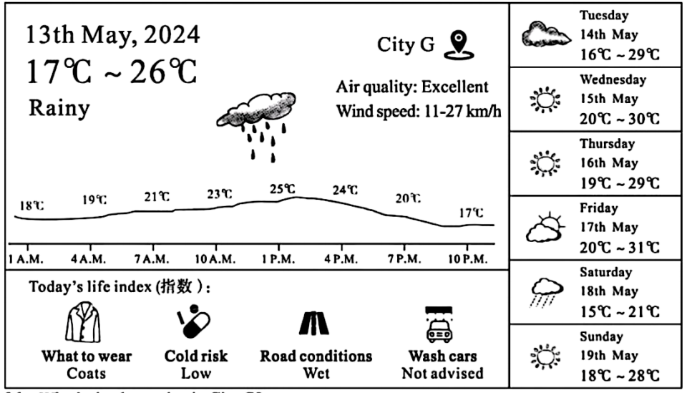

（ A ）16. What’s the date today in City G?
- It’s 13th May. B. It’s 14th May.
- C. It’s 15th May. D. It’s 16th May.
（ B ）17. What’s the temperature at 10:00 am today in City G?
A. It’s 21℃. B. It’s 23℃. C. It’s 25℃. D. It’s 24℃.
（ D ）18 Henry is in City G today. What will most probably happen to him according to the graphics?
A. He will wash his car. B. He will catch a cold.
C. He will ride fast on the road. D. He will wear coats.
（ B ）19. What will the weather be like on Wednesday in City G?
A. It will be rainy. B. It will be sunny.
C. It will be cloudy. D. It will be windy.
（ C ）20. According to the weather report, the highest temperature of this week will be on ________.
A. Sunday B. Saturday C. Friday D. Thursday
B
Bob likes climbing very much. However, there wasn’t one climbing club in his school at first, so he felt sad.
At the beginning of the second year of middle school, his school offered rock climbing lessons in order to encourage students to exercise. He was so happy that he joined at once.
In the first lesson, the coach said, “Rock climbing needs strength, speed, courage and persistence (坚持). All these are necessary.” But in Bob’s opinion, rock climbing was just a fun activity. It interested him.
During the following classes, the coach asked the students to run 1,000 metres first, and then climb with a rope. When Bob finished running, he almost lost his breath (呼吸) and got bored, and he even did not want to touch the rope. He thought it was less interesting than before. The coach noticed that and asked him, “Why do you want to take rock climbing lessons?” “I come for fun, of course.” “Is that fun?” he asked. Bob shook his head slowly. The coach then explained patiently, “That’s because you stop halfway. You know, beautiful sights are always on the top.”
After hearing his words, Bob made up his mind to finish his journey. When he got to the top in the end, he felt really excited.
Sometimes it’s hard to reach the top of the mountain, but it’s a pity to stop halfway, so don’t give up.
（ B ）21. Why did the school offer rock climbing lessons?
A. To develop students’ hobbies. B. To encourage students to exercise.
C. To offer students more clubs. D. To let students enjoy activities.
（ C ）22. How far did the coach ask the students to run first in the rock climbing lessons?
A. One hundred metres. B. One hundred kilometres.
C. One thousand metres. D. One thousand kilometres.
（ B ）23. What does the underlined word “it” refer to in Paragraph (段落) 4?
A. Running. B. Rock climbing
C. Taking lessons. D. Touching the rope.
（ A ）24. How did Bob’s feelings change according to the passage?
A. Sad→happy→bored→excited. B. Excited→sad→bored →happy.
C. Happy→sad→excited→bored. D. Sad→bored→excited→happy.
（ C ）25. What’s the best title of the passage?
A. Learn to Accept Helpful Advice B. Let’s Find the Best Hobby
C. Don’t Give Up Halfway D. Never Stay in the Same Place
C
A sixty-year-old American, Mr. Linden, wears many hats: a writer, a businessman, a traveller, an educator and the founder of a famous hotel. He has lived in a village in Yunnan Province for nearly 20 years. He now considers that he is one of the “cool new Dali people”.
Mr. Linden was born and raised in Chicago. He first visited China in 1984. He received a scholarship (奖学金) from the Chinese Government and came to study in Beijing. During his stay, he was deeply attracted by Chinese culture and would love to be its communicator.
After working and travelling in more than 100 countries, Mr. Linden gave up his job in the US, sold his house and moved to China with his family in 2004. He wanted to find a place and create a new lifestyle. After a tour around China, Mr. Linden and his wife finally decided to live in Xizhou, a small town not far from Dali.
“I’m a fan of China’s traditional buildings. Xizhou is a beautiful town with hundreds of old buildings from the Ming and Qing Dynasties. Traditions here keep as alive as ever and the local people treat me like family,” said Mr. Linden.
With the help of the Dali government, Mr. Linden repaired a traditional Bai-style (白族风格) house into a hotel for foreign tourists. The hotel provides international education projects for European and American schools. It also opens 50% of its room (空间) to the public, creating a place for more people to communicate with the villagers. It offers free English classes to villagers once a week.
When talking about his future plans, Mr. Linden said he wanted to do more to share the beauty of China with the world. “Our goal (目标) is to turn Xizhou into a window for foreigners to learn about China,” said Mr. Linden. “I hope that through my efforts, more people will love China.”
（ D ）26. Mr. Linden does many things EXCEPT ________.
A. Writing B. doing business C. travelling D. working on a farm
（ A ）27. What does the underlined word “attracted” mean in Paragraph 2?
A. 吸引 B. 扩大 C. 丰富 D. 吸收
（ B ）28. Where did Mr. Linden decide to live after a tour around China?
A. In Beijing. B. In Xizhou. C. In Chicago. D. In Nanjing.
（ C ）29. With the help of ________, Mr. Linden repaired a traditional Bai-style house into a hotel.
A. his friends B. foreign tourists
C. the local government D. American schools
（ B ）30. According to the passage, what is Mr. Linden’s goal in the future?
- To repair more ancient buildings.
- B. To let more people know about China.
C. To teach more people English for free. D. To build more hotels.
D
What will the world of tomorrow be like? Many people today believe that technology is going to help solve some problems we have today. New technology may solve old problems, and it may also create new ones. No technology is perfect. Each has advantages and disadvantages. Here are three examples.
When we dream about the future, many of us think that we will be able to fly to the sky in our own flying cars. We could fly at 480 km per hour, avoiding traffic lights and busy roads. However, if too many flying cars are in the air, there will be trouble with traffic control.
3D printing is another new technology for the future. 3D printers are already used to make life-size models of car parts (部件), and man-made body parts, like ears. As we move into the future, 3D printing will change the way we make things and the way we treat sick people. The disadvantage is that such a machine is very expensive.
Finally, people are trying to make a robot suit (套装). This is an electronic suit. It allows people to lift heavy things and walk a long way. It might help people walk again after an illness or an accident. However, one disadvantage at the moment is the cost.
It is easy to imagine a future. We will be able to fly to work, print out a new pair of shoes or lift a car above our heads. Although there are some problems to solve, we can certainly dream of a world. In this world, technology makes people’s life easier and safer, and it can solve some of the most difficult problems we have today.
（ A ）31. How does the writer start the passage?
A. By asking a question. B. By giving a report.
C. By giving advice. D. By telling a story.
（ B ）32. Which one of the following is NOT true?
A. If too many flying cars are in the air, there will be problems with traffic control.
B. 3D printing won’t change the way we make things.
C. A robot suit costs too much at the moment.
D. Technology can solve some of the most difficult problems we have today.
（ C ）33. What might the robot suit help people do after an illness or an accident?
A. It might help people fly to the sky. B. It might help people make models.
C. It might help people walk again. D. It might help people save money.
（ C ）34. What would be the best structure (结构) of this passage?
(Paragraph1=① Paragraph2=② Paragraph3=③ Paragraph4=④ Paragraph5=⑤)
A 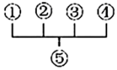 B. 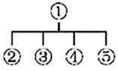 C. 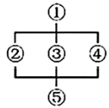 D. 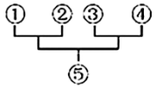
（ D ）35. What is the theme (主题) of the passage?
A. Traffic. B. Machines. C. Clothes. D. Technology.

第二节 口语运用（共5小题，每小题1分，满分5分）
根据下面的对话内容，从文后的选项中选出最佳选项，使对话完整通顺。其中有一项为多余选项。
A: Hi, Linda. What are you doing now?
B: Hi, Tony. ___36___（ B ）
A: What are you going to do this summer?
B: ___37___（ F ）
A: Really? I did that last summer.
B: Oh. ___38___（ D ）
A: I did many things, such as washing clothes, sweeping the floor and talking to them. ___39___（ A ）
B: That sounds interesting.
A: But a lot of old people are lonely. ___40___（ C ）
B: You are right. We are going to be old one day, too.
A: I agree with you.
A. And they told me stories about the past and how things used to be.
B. I am making a plan for the summer vacation.
C. We should take good care of them.
D. What did you do to help them?
E. Which is the way to get there?
F. I am going to work in an old people’s home.
卷Ⅱ（共四部分，满分50分）
第一部分 单词拼写（共20小题，每小题1分，满分20分）
第一节 根据汉语提示，用单词的正确形式填空，每空一词。
41. Have scientists discovered any life out there in space (太空) yet?
42. Judy suddenly realised/realized (意识到) that all her friends were helping her, and she was moved.
43. Diana isn’t sure whether (是否) Betty will come or not.
44. My sister Tina often collects (收集) litter with some volunteers in the park.
45. Don’t be shy (害羞的) when you speak English in public.
46. Boys and girls, you’d better take off your jackets (夹克). It’s hot on the train.
47. Adam has just refused (拒绝) to play football with them because he’s busy with his final exam.
48. It’s important for everyone to keep calm (镇静的) when the earthquake happens.
49. December is the twelfth (第十二) month of a year.
50. The green leaves start to turn gold, then brown in autumn/fall (秋天).

根据短文内容用方框内所给单词的正确形式填空，每空一词，每词一次。
be, neither, instead, sweet, year,
cook, the, surprise, on, understand
In children’s eyes, their mothers are always perfect. In my mind, my mother is good at almost everything but she can’t cook well. I still remember what happened ____51____ my father’s 35th birthday.
My mother began to cook at 9 o’clock in the morning. Three hours later, only two dishes ____52____ served on the table—a salad and a roast duck (烤鸭). My father and I really expected ____53____ roast duck because it was our favourite. Unluckily, the duck was ____54____ nice in colour nor delicious in taste. How disappointed I was! My mother wanted to cook another one. To my ____55____, my father didn’t complain (抱怨) at all. ____56____, he ate one more piece of the duck and smiled at my mother, “Good taste, I love it. Thank you, dear! It’s the best roast duck that I have ever had!” My mother smiled happily and said, “Thank you. Happy birthday!”
I couldn’t ____57____ what my father said at that time. Twenty ____58____ time has passed and my father is 55 years old now. He still loves the food my mother cooks, though she still isn’t good at ____59____. And I get to know that no one is perfect, including my mother. Nothing is perfect, including my family. But love can make a difference. If there is love, home will be the ____60____ place in the world.
51. on；52. were；53. the；54. neither；55. surprise；56. Instead；57. understand ；58. years’；59. cooking；60. sweetest；

第二部分 短文改错（共10小题，每小题1分，满分10分）
下面短文中的画线部分是错误的，请改正，但不得改变原文意思。
Two students were asked to meet the teacher through a forest. There were two path. One was ____61____
short and easy, and the other was full of fallen trees. The first student chooses the easy path. He ____62____
thought he was so clever that he could walk through with any difficulty. He certainly finished first ____63____
and enjoyed him. ____64____
The second student decided to spend time jump over the fallen trees in his path. After arriving at ____65____
the finishing line, he felt tiring and regretted choosing that path. ____66____
The teacher nodded and smiled at all of them. He asked them to get a prize by a stream three days later. ____67____
While the students arrived, they found they needed to jump over the stream. It was a few meters ____68____
widely. The teacher said, “Everything you have done till now ____69____
will be preparing well for this moment. This jump will help you become better.” ____70____
The second student made it at last.
61. paths；62. chose；63. without；64. himself；65. jumping；
66. tired；67. both ；68. When/After；69. wide；70. prepared；

第三部分 任务型阅读（共5小题，每小题2分，满分10分）
阅读下面的短文，然后根据文章内容简要回答第1至5小题。
Once a little weed (杂草) grew in a field. There were many tall and beautiful flowers around it. Lots of bees and butterflies came to them because of their nice smells and bright colours. The little weed wasn’t satisfied, because its flowers were tiny and simple.
One spring morning, three children came to play in the field. “Let’s pick some flowers for our grandma!” said one. “That’s a good idea!” said another. “She will love all these bright and beautiful flowers!”
“What about that one?” the youngest child said, pointing at the little weed. “Forget it!” laughed the oldest brother. “That’s just a useless weed!”
Hearing this, the little weed felt even worse. “Am I really useless?” it asked itself. “Why was I put on the Earth?”
In winter, all flowers were gone, only the little weed stood alone in the field. Just at that time, it noticed some birds coming above the field. “We are hungry!” they shouted. The little weed felt sorry for the poor birds and called out to them, “Hey! Down here! I have pods (豆荚) that you can eat!”
“You’re so kind!” The birds ate up the seeds (种子) in the pods thankfully. “They’re delicious. We can’t find anything better than what you gave us!”
This made the little weed pleased and confident. “At last, I have found out what I am good for!” the little weed said.
71. Why did lots of bees and butterflies come to the flowers? (no more than 8 words)
Because of their nice smells and bright colours.
72. Who did the three children pick the flowers for? (no more than 2 words)
Their grandma.
73. When did the little weed notice the birds come above the field? (no more than 2 words)
In winter.
74. Did the birds think the little weed was useful? (no more than 3 words)
Yes, they did./Yes.
75. How did the little weed feel finally? (no more than 3 words)
Pleased and confident.

第四部分 书面表达（满分10分）
76. 生活里没有书籍，就好像没有阳光；智慧里没有书籍，就好像鸟儿没有翅膀。书香浸润灵魂，阅读陪伴成长。阅读是我们一生的旅程，少年正是读书时，让我们一起读书吧！请根据以下图示及要求以“Reading—a Lifelong Journey”为题，用英语写一篇短文，倡导同学们读书。
要求：
1.字迹工整，书写规范，包含全部图示要点，可适当发挥；
2.文中不得出现真实的姓名、班级和学校名称；
3. 80词左右，开头已给出，不计入总词数；
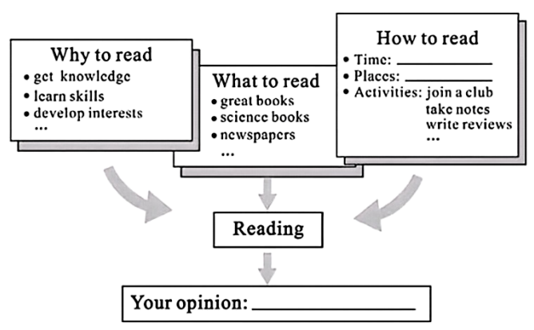
4.请将书面表达内容写在答题卡上的相应位置。

Reading—a Lifelong Journey
As we know, reading plays an important role in our life. We can get knowledge and learn many skills from books. Besides, we can develop interests through reading and make our life colourful.
There are many kinds of books we can read, such as great books, science books and even newspapers. Magazines about study are also good choices for us.
We can read books in our free time, and it’s a good idea to choose a quiet place to read books, like the library. How about joining the Reading Club in our school? While reading, it’s necessary to take notes and write reviews. We can certainly share them with our friends in the club.
In my opinion, reading is a lifelong journey. We can see the world in the books. Let’s read together.
①题材：本文是一篇材料作文；②时态：时态为一般现在时；
③提示：根据提示内容倡导同学们读书，适当增加细节。
[写作步骤]
第一步，介绍读书的好处；
第二步，介绍读什么书；
第三步，介绍如何读书；
第四步，发出号召。
[亮点词汇]
①such as例如
②in our free time在我们的空闲时间
③take notes做笔记
[高分句型]
①There are many kinds of books we can read. (定语从句)
②We can read books in our free time, and it’s a good idea to choose a quiet place to read books, like the library. (and连接的并列句)

