2025版八上英语Unit1语法重点：一般过去时
一、一般过去时的基本用法
1．表示在过去某个时间或某一段时间内发生的动作或存在的状态，常和表示过去的时间状语连用。如yesterday、last week、in 2020、two years ago等。
例：Tom asked me a funny question yesterday.
昨天汤姆问了我一个好笑的问题。
例：Marco Polo began his travels to Asia in 1271.
1271年，马可·波罗开始了他的亚洲之行。

2.表示过去经常或反复发生的动作，常和表示频度的副词连用。
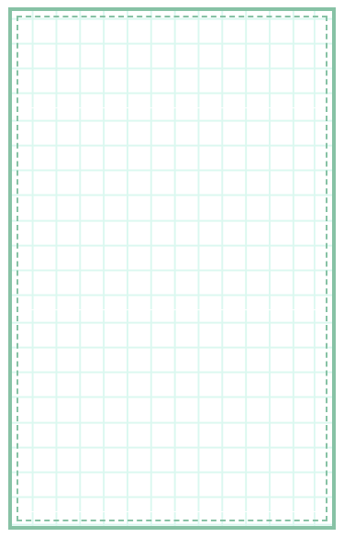
例：He often ran in the morning last year.
去年他经常在早上跑步。

二、一般过去时的基本句式
句子类型 | 含系动词 be | 含行为动词
肯定句 | 主语 + was/were + 其他. | 主语 + 动词过去式 + 其他.
否定句 | 主语 + was/were + not +其他. | 主语 + didn't + 动词原形 + 其他.
一般疑问句  肯定回答  否定回答 | Was/Were + 主语 + 其他? | Did + 主语 + 动词原形 + 其他?
一般疑问句  肯定回答  否定回答 | Yes, 主语 + was/were. | Yes, 主语 + did.
一般疑问句  肯定回答  否定回答 | No, 主语 + wasn't/weren't. | No, 主语 + didn't.
例：Chen Jie was in the library yesterday.
陈洁昨天在图书馆里。
例：Chen Jie wasn't in the library yesterday.
陈洁昨天不在图书馆里。
例：—Was Chen Jie in the library yesterday?
陈洁昨天在图书馆里吗?
—Yes,she was./No,she wasn't. 是的,她在。/不,她不在。
例：Sam visited the Great Wall last week.
萨姆上周参观了长城。
例：Sam didn't visit the Great Wall last week.
萨姆上周没参观长城。
例：Did Sam visit the Great Wall last week?
萨姆上周参观长城了吗?
Yes,he did./No,he didn't. 是的，他参观了。/不,他没参观。

三、过去式的规则变化
类别 | 构成方法 | 例词与发音 | 读音规则
一般情况 | 加-ed | play—played  offer—offered  start—started | 清辅音后读/t/，浊辅音和元音后读/d/，/t/和/d/后读/ɪd/
以e结尾的动词 | 加-d | like—liked  hate—hated  live—lived | 清辅音后读/t/，浊辅音和元音后读/d/，/t/和/d/后读/ɪd/
以“辅音字母+y”结尾的动词 | 变y为i，再加-ed | cry—cried  study—studied  carry—carried | 清辅音后读/t/，浊辅音和元音后读/d/
以重读闭音节结尾，且末尾只有一个辅音字母的动词 | 双写最后一个辅音字母，再加-ed | plan—planned  stop—stopped  shop—shopped | 清辅音后读/t/，浊辅音和元音后读/d/

四、过去式的不规则变化
不规则动词的过去式变化需要特殊记忆，大致可分为以下几种：
变化 | 例词
保持不变 | set-set cut-cut
遇见i，a来替 | sit-sat swim-swam
ow/aw变ew | draw-drew know-knew
结尾d，变成t | lend-lent build-built
ought/aught替 | catch-caught buy-bought
【奇思巧计】
规则动词过去式的构成
过去式构成有规律，一般词尾加-ed。
如果词尾有个e，直接加-d就可以。
辅音字母y结尾，变y为i加-ed。
一辅重闭作尾巴，双写之后加-ed。

【同步检测】
一、单选题
（ C ）1、—________ Peter ________ his friends on the Dragon Boat Festival?
—No, he visited his grandparents instead.
A．Did; visited B．Does; visit C．Did; visit D．Does; visited
（ D ）2、—Did you buy a gift for your father on Father’s Day this year?
—Of course. I _____ a tie for him and he was happy with it.
A．buy B．buys C．will buy D．bought
（ C ）3、We often play soccer on Sunday afternoon, but last Sunday afternoon we ________ ping pong.
A．play B．plays C．played D．playing
（ D ）4、There ________ three bananas in the bag a moment ago. Did you see them?
A．is B．was C．are D．were
（ C ）5、—________ you tired after jogging in the park for two hours?
— No, I ________ feel tired. Instead, I was full of energy.
A．Did; didn’t B．Were; wasn’t
C．Were; didn’t D．Did; wasn’t

视频同款学习资料
想要的家长看主页橱窗
选中小学教辅图书
全网搜“帝源教育”

二、句型转换
1、Linda used to be a dancer. （改为一般疑问句）
Did Linda use to be a dancer?
2、Cindy went to Shanghai last weekend. (改为否定句)
Cindy didn’t go to Shanghai last weekend.
3、He asked the policeman for help. (改为一般疑问句)
Did he ask the policeman for help?
4、My grandpa did some exercises yesterday. (改为否定句)
My grandpa didn’t do any exercises yesterday.
5、I went to Linda’s birthday party last night. （改为一般疑问句）
Did you go to Linda’s birthday party last night?
6、Jack set off for Paris yesterday.（改为一般疑问句）
Did Jack set off for Paris yesterday?
7、The emperor became angry again. (改为一般疑问句并作否定回答)
—Did the emperor become angry again?—No, he didn’t.

