2025~2026学年七年级英语上册（人教版）单元测试卷
Unit 1：You and Me
学校： 班级： 姓名： 分数： .
一、根据首字母完成单词
1.If you want to know more information，you can ask me for help.
2.Would you like to make friends with them?
3.Andre Kalu has some other hobbies，such as playing the guitar and singing.
4.She has a twin sister. They look the same.
5.China is a great country with a lot of delicious food.
6.Peter Brown is student in Class 8，Grade 7.
7.The parrot is smart and it can speak.
8.I often play tennis with my sister after school.
9.Coco is only three years old. She even speaks some Chinese.
10.My father is a sports lover. He plays basketball every weekend/week.

二、根据中文提示填入合适的代词
1.I don’t know your name. Can you tell me?(你)
2.These are my boxes. I put them over there.(我)
3.He is my brother and he is a student.(他)
4.I have a good friend. Her name is Lucy. She is twelve.(她)
5.—What is its name? — It is Mimi.(它)
6.—Are your (你们的) names Lucy and Lily? —Yes，we are.
7.—Are we all here today? —No，our monitor (班长) is not here.(我们)
8.—Are they (它们) their (他们) keys?
—No，they (它们) aren’t. Their (他们的) keys are over there.
9. I am a girl. My name is Cindy.(我)
10.Look at the boy. His(他的) first name is Bob.

三、用be动词的适当形式填空
1.—I am Tom. Are you Mary? —No，I am not.
2.The girl is Jack’s sister.
3.The man with big eyes is a teacher.
4. Is your brother in the classroom?
5.How is your father?
6.Mike and Liu Tao are at school.
7.Who am I?
8.Her name is Anna.
9.The pen and pencil are in the pencil box.
10.The colour of the pictures is black.

四、按要求完成下列各题，每空一词
1.Is he Frank?(作否定回答)
No，he isn't.
2.Jane is my friend. Suzy is my friend.(合并为一句)
Jane and Suzy are my friends.
3.His first name is Dale.(对画线部分提问)
What’s his first name ?
4.She’s Zhang Lingling.(改为一般疑问句)
Is she Zhang Lingling?
5.His first name is Bob. His last name is Smith.(合并为一句)
His name is Bob Smith.
6.你在中国吗?(完成译句)
Are you in China ?
五、完形填空
Hey，friends! I’m Alice. I’m a 1 from the UK，but I’m in China now. My 2 is Xu Ruike. Xu is my 3 name and Ruike is my 4 name. Xu Yajun is my 5 Chinese name. 6 English name is Mike. Look! These are my three 7 . We 8 in the same class. Their names are Dale，Elly
9 Lily. Dale is a clever boy. Elly and Lily 10 sisters. They are nice. For colours，Dale likes 11 ，and he has an orange jacket. Elly and Lily 12 red. 13 I like white best. I have a 14 cap. And my favourite sport is 15 .
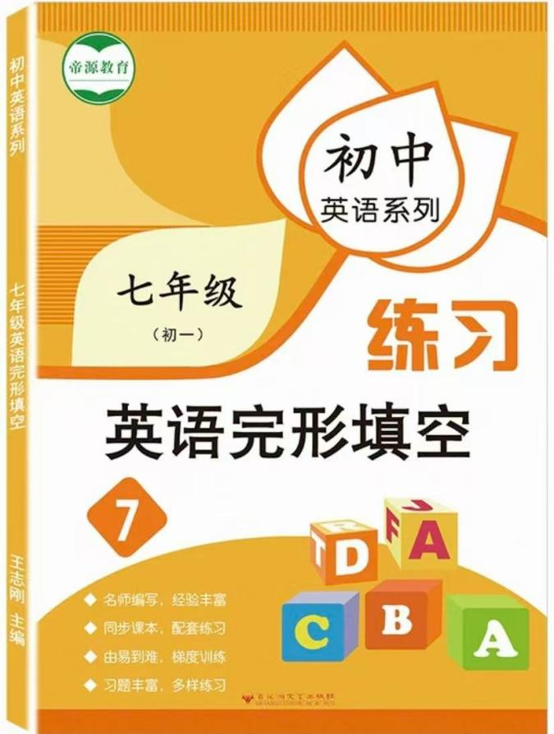
视频同款学习资料
想要的家长看主页橱窗
选中小学教辅图书
全网搜“帝源教育”

( C )1. A.name B.school C.girl D.book
( D )2. A.first name B.last name C.family name D.Chinese name
( B )3. A.first B.last C.full D.given
( A )4. A.first B.last C.next D.one
( B )5. A.mother’s B.father’s C.sister’s D.brothers
( C )6. A.Her B.Your C.His D.My
( B )7. A.friend B.friends C.brother D.sister
( D )8. A.am B.is C./ D.are
( B )9. A.too B.and C.well D.but
( C )10. A.is B.am C.are D.be
( C )11. A.name B.purple C.orange D.book
( D )12. A.spell B.say C.look D.like
( A )13. A.But B.Or C.Yes D.So
( A )14. A.white B.last C.good D.black
( B )15. A.cat B.basketball C.books D.noodles

六、书面表达
假设你是张华，寒假你将去美国研学，并住在Mrs Smith的家里。为了更好地照顾你，她想了解你的一些基本信息和爱好。请你根据下表信息给她写一封电子邮件，告诉她你的相关情况。
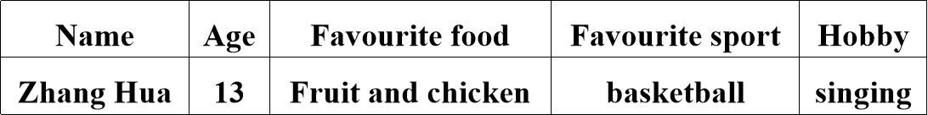

2025~2026学年七年级英语上册（人教版）单元测试卷
Unit 1：You and Me
学校： 班级： 姓名： 分数： .
一、根据首字母完成单词
1.If you want to know more information，you can ask me for help.
2.Would you like to make friends with them?
3.Andre Kalu has some other hobbies，such as playing the guitar and singing.
4.She has a twin sister. They look the same.
5.China is a great country with a lot of delicious food.
6.Peter Brown is student in Class 8，Grade 7.
7.The parrot is smart and it can speak.
8.I often play tennis with my sister after school.
9.Coco is only three years old. She even speaks some Chinese.
10.My father is a sports lover. He plays basketball every weekend/week.

二、根据中文提示填入合适的代词
1.I don’t know your name. Can you tell me?(你)
2.These are my boxes. I put them over there.(我)
3.He is my brother and he is a student.(他)
4.I have a good friend. Her name is Lucy. She is twelve.(她)
5.—What is its name? — It is Mimi.(它)
6.—Are your (你们的) names Lucy and Lily? —Yes，we are.
7.—Are we all here today? —No，our monitor (班长) is not here.(我们)
8.—Are they (它们) their (他们) keys?
—No，they (它们) aren’t. Their (他们的) keys are over there.
9. I am a girl. My name is Cindy.(我)
10.Look at the boy. His(他的) first name is Bob.

三、用be动词的适当形式填空
1.—I am Tom. Are you Mary? —No，I am not.
2.The girl is Jack’s sister.
3.The man with big eyes is a teacher.
4. Is your brother in the classroom?
5.How is your father?
6.Mike and Liu Tao are at school.
7.Who am I?
8.Her name is Anna.
9.The pen and pencil are in the pencil box.
10.The colour of the pictures is black.

四、按要求完成下列各题，每空一词
1.Is he Frank?(作否定回答)
No，he isn't.
2.Jane is my friend. Suzy is my friend.(合并为一句)
Jane and Suzy are my friends.
3.His first name is Dale.(对画线部分提问)
What’s his first name ?
4.She’s Zhang Lingling.(改为一般疑问句)
Is she Zhang Lingling?
5.His first name is Bob. His last name is Smith.(合并为一句)
His name is Bob Smith.
6.你在中国吗?(完成译句)
Are you in China ?
五、完形填空
Hey，friends! I’m Alice. I’m a 1 from the UK，but I’m in China now. My 2 is Xu Ruike. Xu is my 3 name and Ruike is my 4 name. Xu Yajun is my 5 Chinese name. 6 English name is Mike. Look! These are my three 7 . We 8 in the same class. Their names are Dale，Elly
9 Lily. Dale is a clever boy. Elly and Lily 10 sisters. They are nice. For colours，Dale likes 11 ，and he has an orange jacket. Elly and Lily 12 red. 13 I like white best. I have a 14 cap. And my favourite sport is 15 .
视频同款学习资料
想要的家长看主页橱窗
选中小学教辅图书
全网搜“帝源教育”

( C )1. A.name B.school C.girl D.book
( D )2. A.first name B.last name C.family name D.Chinese name
( B )3. A.first B.last C.full D.given
( A )4. A.first B.last C.next D.one
( B )5. A.mother’s B.father’s C.sister’s D.brothers
( C )6. A.Her B.Your C.His D.My
( B )7. A.friend B.friends C.brother D.sister
( D )8. A.am B.is C./ D.are
( B )9. A.too B.and C.well D.but
( C )10. A.is B.am C.are D.be
( C )11. A.name B.purple C.orange D.book
( D )12. A.spell B.say C.look D.like
( A )13. A.But B.Or C.Yes D.So
( A )14. A.white B.last C.good D.black
( B )15. A.cat B.basketball C.books D.noodles

六、书面表达
假设你是张华，寒假你将去美国研学，并住在Mrs Smith的家里。为了更好地照顾你，她想了解你的一些基本信息和爱好。请你根据下表信息给她写一封电子邮件，告诉她你的相关情况。

Dear Mrs Smith,
I am very happy to get your email and I'm writing to tell you something about myself.
My name is Zhang Hua. I am 13 years old. I am from Hangzhou, China. I am a middle school student in Grade Seven. I live with my big family.
For food, I like fruit and chicken because they are good for my health. I am a sports lover and my favourite sport is basketball. I often play basketball with my friends after school.I also like singing. I am in the school music club.
I believe I will have a good time with you. I can't wait to see you.
Yours,
Zhang Hua

