九年级英语全一册Unit2课堂笔记知识点
一、核心短语与固定搭配
1、节日相关
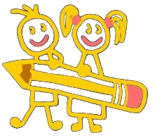
the Lantern Festival（元宵节）
the Dragon Boat Festival（端午节）
the Water Festival（泼水节）
the Mid-Autumn Festival（中秋节）
Christmas Eve（圣诞夜）
2、动词短语
put on five pounds（体重增加五磅）
lay out（摆开；布置）
throw water at each other（互相泼水）
dress up（乔装打扮）
give out（分发）
end up（最终成为）
shoot down（射下）
warn sb. to do sth.（警告某人做某事）

3、形容词与名词短语
be similar to...（与……相似）
in the shape of...（呈……的形状）
the importance of...（……的重要性）
the spirit of...（……的精神）
a time for doing sth.（做某事的时候）
4、其他实用短语
not only...but also...（不但……而且……）
as a result（结果）
care about（关心）
remind sb. of...（使某人想起……）
spread love and joy（传播爱与欢乐）

二、重点词汇解析
1、put on
增加体重：I can eat what I want but I never put on weight.
穿上：Put on your coat before going outside.
上演：The band is putting on a show tonight.
2、wish vs. hope
wish：后接宾语从句时用虚拟语气（如 I wish I were rich.），或接双宾语（We wish you a happy journey!）。
hope：后接宾语从句或不定式（I hope to visit Paris.），不可接双宾语。
3、dress up
装扮成：He dressed up as a ghost for Halloween.
穿上盛装：She dressed up in red for the party.
4、lay out
布置：My mother laid out the table for dinner.
花费（时间/金钱）：He laid out a fortune on his new car.

三、语法精讲
1、宾语从句
引导词：
陈述句用 that（可省略）：I think (that) mooncakes are delicious.
一般疑问句用 if/whether：I wonder if it will rain tomorrow.
特殊疑问句用 who/what/when/where：Can you tell me where the restroom is?
时态规则：
主句一般现在时，从句任意时态：She says she is reading.
主句一般过去时，从句用过去时态：He said he had finished his homework.
客观真理用一般现在时：The teacher told us the earth orbits the sun.
否定转移：主句为 I think/believe 时，否定在从句：I don’t think he is right.（而非 I think he isn’t right.）
2、感叹句
What型：What + (a/an) + adj. + n. + 主谓!
What a delicious cake it is!
How型：How + adj./adv. + 主谓!
How beautifully she sings!
3、反义疑问句
肯定陈述 + 否定提问：She is a student, isn’t she?
否定陈述 + 肯定提问：You don’t like coffee, do you?
含否定词（little/few/never）时，反义疑问句用肯定：He knows little English, does he?

四、句型与功能句
1、表达喜好
I like the Dragon Boat Festival best because of the races.
What do you like best about the Mid-Autumn Festival?
2、询问与应答
I wonder if the Water Festival is similar to Songkran in Thailand.
Yes, they both involve throwing water at each other!
3、感叹与评价
How fantastic the dragon boat teams were!
What a meaningful tradition it is to share mooncakes with family!
4、文化对比
Christmas is similar to the Spring Festival in China—both are times for family reunions.

五、文化拓展
1、节日象征
月饼（mooncakes）象征团圆，常呈圆形（in the shape of a full moon）。
端午节赛龙舟（dragon boat races）纪念屈原。
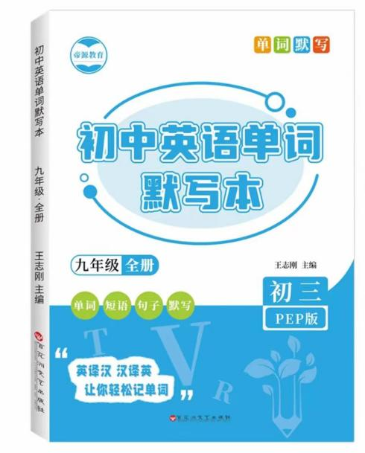
视频同款学习资料
想要的家长看主页橱窗
选中小学教辅图书
全网搜“帝源教育”

2、西方节日
Halloween（万圣节）：trick or treat（不给糖就捣蛋），dress up as ghosts。
Christmas：lay out gifts under the Christmas tree，spread joy and love。
六、易错点提醒
1、宾语从句语序：必须用陈述语序（I know where he lives.，而非 I know where does he live.）。
2、wish与hope：wish 后接虚拟语气，hope 后接现实可能。
3、put on与wear：put on 强调动作，wear 强调状态（She is wearing a red dress.）。

