九年级英语Unit 1用单词的适当形式填空
学校： 班级： 姓名： 分数： .
1．Sometimes I feel stressed（stress）because of my parents’ high expectations.
2．The doctor old has a good understanding (understand) of health.
3．Could you tell me how to practice speaking (speak) English?
4．He didn't finish giving（give）a report yesterday.
5．Don’t be afraid of making (make) mistakes when you talk to foreigners in English.
6．My parents are very impressed (impress) by my great progress.
7．It’s not easy for me to follow (follow) the teachers because they speak too quickly.
8．It’s amazing (amaze) how much it helps.
9．At first, they argued with each other. Later on, they ended up fighting (fight).
10．Read every day to practice your pronunciation (pronounce).
11．Are you excited about traveling/travelling (travel) to Asia?
12．Practice memorizing (memorize) articles, and you will be able to say complete sentences.
13．After a serious illness, he finally realized (realize) the importance of health.
14．The two sentences are very useful (use). Please write them down.
15．Who hid (hide) the basketball behind the tree? It took me much time to find it.
16．Children in some Western countries like to play a game called (call) “trick or treat” on Halloween.
17．The dancers clap loudly (loud) while moving around each other.
18．The price of oil increased (increase) last year. How about the price this year?
19．The little boy has a lot of partners (partner) to play with, so he doesn’t feel lonely.
20．The boy pronounced (pronounce) the word again and again until he could write it.
21．Although he is tired, he still keeps working (work).
22．She is a clever girl and she always answers the teacher’s questions actively(active).
23．Bob first got interested (interest) in motorcycles when he was about sixteen.
24．The man has the ability(able) to do the job well. We all trust him.
25．They talk with each other through body language and the expressions on their faces. (expression)
26．Mrs. Smart warned (warn) her students not to stay out late last night.
27．We should try to practice the pronunciation of new words after class. (pronounce)
28．Many students came to see Tom and brought him some presents (present) and flowers.
29．Mike was punished (punish) by our head teacher for his behavior was against the school rules.
30．I asked the police to help me find out who stole (steal) my wallet.
31．Mr. Zhang is good at writing and he writes novels (novel) in his spare time.
32．Some traditional (tradition) Chinese cartoon characters like Monkey King are loved by people of all ages.
33．The two lovely cats lay (lie) on the sofa and looked at Mrs. Lee.
34．Doing outdoor activities can help students improve their learning abilities (ability) and skills.
35．In my opinion, there must be life on other planets though none has been discovered (discover).
36．We should learn from our mistakes and try our best to avoid repeating(repeat) them.
37．Mr. Wang explained the answer to us patiently (patient) until all of us understood it.
38．We are preparing a birthday party secretly(secret) to give Mom a surprise.
39．New technology solve old problems and it may also create new ones. (creative)
40．He is poor in money, but rich in knowledge（know）.
41．It is said that a Chinese ruler called Shen Nong was the first to discover
(discover) tea as a drink.
42．Our Chinese teacher often says it’s good for us to memorize more Chinese poems. (memory)
43．Bob is so clever that he always learns wisely (wise).
44．After the COP14, we all have a better understanding (understand) of protecting the wetland(湿地).
45．Work hard and you’ll find it easy to achieve (achieve) your dream.
46．We save electricity by turning (turn) off the lights when we leave a room.
47．Tom didn’t pay attention to listening (listen) to the teacher, so he couldn’t finish the work.
48．When we questioned (question) John about the matter, he finally told the truth.
49．I think Jack has the ability (able) to deal with the problem well.
50．Whether or not you can do this well depends (depend) on your learning habits.
51．Do you know how to spell (spell) the word?
52．I usually learn English by memorizing (memorize) sentence patterns and reading books and newspapers.
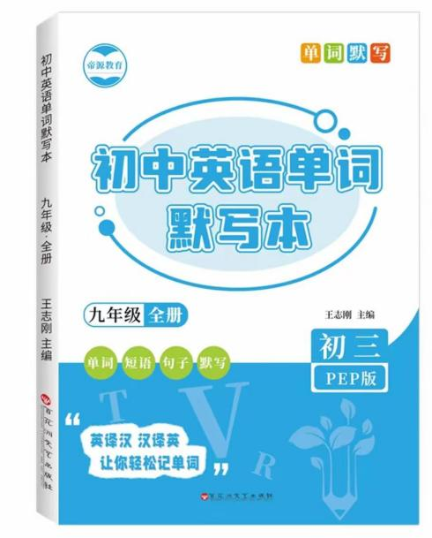
视频同款学习资料
想要的家长看主页橱窗
选中小学教辅图书
全网搜“帝源教育”

53．The losers in our life or work are always the most impatient (patient).
54．The Chinese language has become a bridge connecting (connect) China to the rest of the world.
55．I’d like to decorate my house in an American style to create (creative) a relaxing feeling.
56．I don’t know how to get my pronunciation (pronounce) right.
57．As students, we must have the ability (able) of teaching ourselves.
58．I can’t connect (connect) my computer to the Internet. There must be something wrong.
59．Children are supposed to get 60 minutes of physical activity/activities (active) every day.
60．We are very busy now. Because we’ll have a physics test. (physical)
九年级英语Unit 1用单词的适当形式填空
学校： 班级： 姓名： 分数： .
1．Sometimes I feel stressed（stress）because of my parents’ high expectations.
2．The doctor old has a good understanding (understand) of health.
3．Could you tell me how to practice speaking (speak) English?
4．He didn't finish giving（give）a report yesterday.
5．Don’t be afraid of making (make) mistakes when you talk to foreigners in English.
6．My parents are very impressed (impress) by my great progress.
7．It’s not easy for me to follow (follow) the teachers because they speak too quickly.
8．It’s amazing (amaze) how much it helps.
9．At first, they argued with each other. Later on, they ended up fighting (fight).
10．Read every day to practice your pronunciation (pronounce).
11．Are you excited about traveling/travelling (travel) to Asia?
12．Practice memorizing (memorize) articles, and you will be able to say complete sentences.
13．After a serious illness, he finally realized (realize) the importance of health.
14．The two sentences are very useful (use). Please write them down.
15．Who hid (hide) the basketball behind the tree? It took me much time to find it.
16．Children in some Western countries like to play a game called (call) “trick or treat” on Halloween.
17．The dancers clap loudly (loud) while moving around each other.
18．The price of oil increased (increase) last year. How about the price this year?
19．The little boy has a lot of partners (partner) to play with, so he doesn’t feel lonely.
20．The boy pronounced (pronounce) the word again and again until he could write it.
21．Although he is tired, he still keeps working (work).
22．She is a clever girl and she always answers the teacher’s questions actively(active).
23．Bob first got interested (interest) in motorcycles when he was about sixteen.
24．The man has the ability(able) to do the job well. We all trust him.
25．They talk with each other through body language and the expressions on their faces. (expression)
26．Mrs. Smart warned (warn) her students not to stay out late last night.
27．We should try to practice the pronunciation of new words after class. (pronounce)
28．Many students came to see Tom and brought him some presents (present) and flowers.
29．Mike was punished (punish) by our head teacher for his behavior was against the school rules.
30．I asked the police to help me find out who stole (steal) my wallet.
31．Mr. Zhang is good at writing and he writes novels (novel) in his spare time.
32．Some traditional (tradition) Chinese cartoon characters like Monkey King are loved by people of all ages.
33．The two lovely cats lay (lie) on the sofa and looked at Mrs. Lee.
34．Doing outdoor activities can help students improve their learning abilities (ability) and skills.
35．In my opinion, there must be life on other planets though none has been discovered (discover).
36．We should learn from our mistakes and try our best to avoid repeating(repeat) them.
37．Mr. Wang explained the answer to us patiently (patient) until all of us understood it.
38．We are preparing a birthday party secretly(secret) to give Mom a surprise.
39．New technology solve old problems and it may also create new ones. (creative)
40．He is poor in money, but rich in knowledge（know）.
41．It is said that a Chinese ruler called Shen Nong was the first to discover
(discover) tea as a drink.
42．Our Chinese teacher often says it’s good for us to memorize more Chinese poems. (memory)
43．Bob is so clever that he always learns wisely (wise).
44．After the COP14, we all have a better understanding (understand) of protecting the wetland(湿地).
45．Work hard and you’ll find it easy to achieve (achieve) your dream.
46．We save electricity by turning (turn) off the lights when we leave a room.
47．Tom didn’t pay attention to listening (listen) to the teacher, so he couldn’t finish the work.
48．When we questioned (question) John about the matter, he finally told the truth.
49．I think Jack has the ability (able) to deal with the problem well.
50．Whether or not you can do this well depends (depend) on your learning habits.
51．Do you know how to spell (spell) the word?
52．I usually learn English by memorizing (memorize) sentence patterns and reading books and newspapers.
视频同款学习资料
想要的家长看主页橱窗
选中小学教辅图书
全网搜“帝源教育”

53．The losers in our life or work are always the most impatient (patient).
54．The Chinese language has become a bridge connecting (connect) China to the rest of the world.
55．I’d like to decorate my house in an American style to create (creative) a relaxing feeling.
56．I don’t know how to get my pronunciation (pronounce) right.
57．As students, we must have the ability (able) of teaching ourselves.
58．I can’t connect (connect) my computer to the Internet. There must be something wrong.
59．Children are supposed to get 60 minutes of physical activity/activities (active) every day.
60．We are very busy now. Because we’ll have a physics test. (physical)

