2025秋九年级英语第一次月考作文押题
月考作文押题【一】
开学已经有好几周了，和以前相比你的学习和生活都变得更好了。请以I have changed for the better为题写一篇80词左右的作文，描述一下你与过去相比所发生的可喜的变化。
❤【范文】
I have changed for the better
Several weeks has passed since the new term started. Looking back, I’m delighted to find that l’ve changed for thebetter in both study and life.
In the past, often procrastinated and left homework until the last minute, Now, l make a detailed plan every day andfinish tasks on time. Also, l used to be shy and afraid to speak in public, But now, l actively take part in class discussionsand school activities.
These changes make me more confident and efficient. i’ll keep moving forward!
❤【翻译】
我已经变得更好
新学期开始已经几周了。回首过去，我很高兴地发现，无论在学习还是生活上，我都变得更好。
过去，我经常拖延，把作业留到最后一刻才做。现在，我每天都会制定详细的计划，并按时完成任务。此外，我以前很害羞，害怕在公共场合发言，但现在，我积极参加课堂讨论和学校活动。
这些改变让我更加自信和高效。我会继续前进！
2025秋九年级英语第一次月考作文押题
月考作文押题【二】
青少年在成长过程中会遇到各种问题，为此《21世纪英文报》开设了Teens Talk专栏，倾听读者的心声，并由“少年之友”Sigmund Friend予以回复。假设你是李华，最近也遇上了烦心事，请给该专栏发一封英文邮件，讲述你的烦恼并寻求建议。
❤【范文】
Dear Mr. Friend,
I’m writing to you about the problem I’m facing at the moment.
These days l’m not happy. l always argue with my parents. They only care about my schoolwork. The summer holiday iscoming. They plan to choose lots of after-school classes for me. But l don’t want to take these classes and don’t want to be sobusy. l’ m interested in painting. l just want to take painting lessons during the holiday. They disagree with me. l don’t know whatto do. And how can l improve the relationship with my parents? Can you give me some advice?
I’m looking forward to hearing from you soon.
Yours sincerely,
Li Hua
❤【翻译】
亲爱的朋友，
我写信给您，是想向您倾诉我目前所面临的问题。 这些天我并不开心。我总是和父母争吵。他们只关心我的学业。暑假即将来临。他们打算给我报很多课外班。但我不想上这些课，也不想那么忙。我对绘画感兴趣。我只想在假期上绘画课。他们不同意我的想法。我不知道该怎么办。我该如何改善与父母的关系？你能给我一些建议吗？
我期待着能尽快收到你的消息。
此致，李华
2025秋九年级英语第一次月考作文押题
月考作文押题【三】
根据下面要点，以“My new friend”为题，介绍你的新朋友Andy。
性格 | 自信，…（举例）；有条理，…（举例）；
喜爱的颜色 | 蓝色，…（原因）；绿色，…（原因）；
座右铭(Motto) | 体型大小并不重要；  如果永不言弃，可以做任何事情。
问题 | 不擅长体育，…；父母太在意分数、压力过大；
你的建议 | …（针对Andy的问题，提出一至两条建议）
❤【范文】
My new friend
Andy is my new friend. He is a confident boy who always believes in himself. For example, he never hesitates to answerguestions in class, He is also well-organized-his notes are always neat and his schedule is carefully planned.
Andy loves blue because it reminds him of the calm ocean. He also likes green because it represents hope and energyto him. His motto is, "Size doesn't matter, if you never give up, you can do anything."
However, Andy has some problems. He is not good at sports and often feels stressed because his parents care toomuch about his grades. l suggest he practice sports step by step and talk to his parents about his feelings.
Andy is a great friend, and l hope he can overcome his difficulties.
❤【翻译】
我的新朋友
安迪是我的新朋友。他是一个自信的男孩，总是相信自己。例如，他在课堂上从不犹豫地回答问题。他做事有条理，笔记总是整洁有序，日程安排也经过精心规划。
安迪喜欢蓝色，因为它让他想起平静的海洋。他也喜欢绿色，因为绿色对他而言代表着希望和活力。他的座右铭是：“大小并不重要，只要永不放弃，你就能做成任何事。”
然而，安迪有一些问题。他不擅长运动，而且因为父母过于关心他的成绩而经常感到压力。我建议他逐步练习运动，并与父母谈谈自己的感受。
安迪是个很好的朋友，我希望他能克服困难。
2025秋九年级英语第一次月考作文押题
月考作文押题【四】
假设你有一个名叫Tom的好朋友，进入初三后他变化了很多，请根据以下表格内容介绍一下他在学习、生活中的成长变化。
简介 | 15岁，九年级学生。最喜欢橙色，因为橙色可以使人振作。
过去 | 有太多家庭作业，别无选择只能熬夜。  不仅常玩电脑游戏而且拒绝和父母交流。
现在 | 有条理，仔细计划每一天……很勤奋，在学习上对自己严格要求……很自信，参加了校篮球队的选拔并且证明了……
将来 | 想成为一个……（理由）
❤【范文】
Tom is my good friend. He has changed a lot. Let me introduce what he has changed
He is 15 years old boy. And he is student in a middle school. He is in Class 1, Grade 9. Yellow is his favorite color because hethinks that yellow can cheer him up. He used to has a lot of homework. He has no choice but to stay up late. He used to playcomputer games, and he refused to tak with his parents. But now he wants to live a good day. He makes a good plan every dayAnd he studies hard, he is strict with his study. He is more confident than before. He joins the school basketball team.
He wants to be a famous basketball player all over the world. Because he loves basketball very much and he wants to befamous.
❤【翻译】
汤姆是我的好朋友。他变化很大。让我来介绍一下他有哪些变化
他是一个15岁的男孩。他是一名中学生，就读于九年级一班。他最喜欢的颜色是黄色，因为他认为黄色能让他心情愉悦。他过去常常有很多作业，不得不熬夜完成。他过去常常玩电脑游戏，并且拒绝与父母沟通。但现在，他想要过上美好的一天。他每天都会制定一个良好的计划，并且努力学习，严格要求自己。他比以前更加自信了。他加入了学校的篮球队。
他想成为一位世界闻名的篮球运动员。因为他非常热爱篮球，并且他想出名。
2025秋九年级英语第一次月考作文押题
月考作文押题【五】
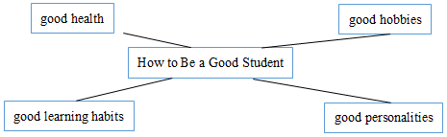
青年者，国家之魂。一个民族只有寄望青春、永葆青春，才能兴旺发达。请根据下图提示，以“How to Be a Good Student” 为题，谈谈我们应该怎样做好自己，不负时代赋予我们的责任。

❤【范文】
How to Be a Good Student
It’s very important to be a good student. As teenagers, what should we do?
First of all, it is important for us to keep healthy, We can do some sports, such as running or playing basketball. Doing sportsmakes us strong. We should also have a healthy diet. Besides, we should go to bed early and get up early. Secondly, we shoulddevelop our own good hobbies. Good hobbies like listening to music can make us feel happy. Thirdly, politeness and helpfuinessare necessary. We should always be ready to help those in need. We should be honest and never ie, Last but not least, we shoulddevelop good learning habits. We must listen carefully to the teacher in class. We can review as much as possible and prepare fornew knowledge in a timely manner. in addition, we can read different types of books in our free time.
I hope everyone can do the best to be a good student.
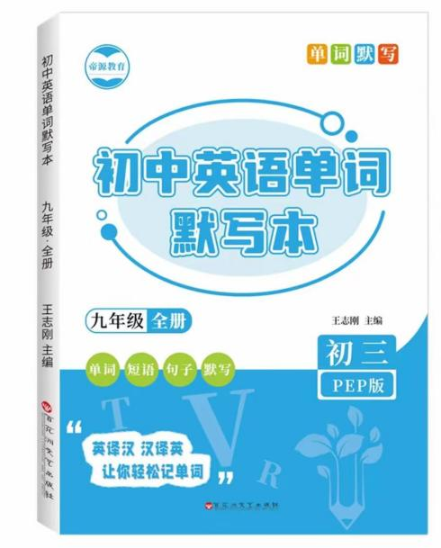

视频同款学习资料
想要的家长看主页橱窗
选中小学教辅图书
全网搜“帝源教育”

❤【翻译】
如何成为一名好学生
做一个好学生非常重要。作为青少年，我们应该做些什么呢？
首先，保持健康对我们来说很重要。我们可以做一些运动，比如跑步或打篮球。运动让我们强壮。我们还应该保持健康的饮食。此外，我们应该早睡早起。其次，我们应该培养自己的良好爱好。像听音乐这样的好爱好能让我们感到快乐。第三，礼貌和乐于助人也是必要的。我们应该随时准备帮助那些需要帮助的人。我们应该诚实，绝不撒谎。最后但同样重要的是，我们应该养成良好的学习习惯。在课堂上，我们必须认真听讲。我们可以尽可能多地复习，并及时为新知识做好准备。此外，我们可以在空闲时间阅读不同类型的书籍。
我希望每个人都能尽自己最大的努力，成为一名优秀的学生。

