七上英语第一次月考作文押题及范文
月考作文押题【一】
Peter是一名英国学生，正在网上寻找笔友。假如你叫王平（请不要写真实姓名），请用英语给Peter写封信，介绍你自己、你的家庭、学习情况和个人爱好等，信的词数60左右。
【范文】
Dear Peter,
I know you are a middle school student. My name is Wang Ping. My English name is Dennis. l 'm twelve years old. l amfrom jilin Province ,China. l'm a student, too. l like English, so l want to make a pen pal with you. in my free time, l likelistening to music, playing football and watching movies. but my favorite hobby is playing chess.l have classes fromMonday to Friday.l have ten classes every day. what about you?Please write to me soon.
Yours,
Wang Ping
【翻译】
亲爱的彼得，
我知道你是一名中学生。我叫王平，英文名叫丹尼斯。我今年十二岁，来自中国吉林省。我也是一名学生。我喜欢英语，所以我想和你交个笔友。在空闲时间，我喜欢听音乐、踢足球和看电影。但我最喜欢的爱好是下棋。我周一至周五都有课，每天上十节课。你呢？请尽快给我回信。
你的，王平
七上英语第一次月考作文押题及范文
月考作文押题【二】
丰富多彩的暑假生活已经结束，你是如何度过自己的暑假生活，你认为你的暑假生活怎么样？请以“My Summer Holiday”为题，写一篇短文。
【范文】
My Summer Holiday
This year l had a very meaningful summer holiday. Unlike many other students, i didn't spend all my time playing computer games.Instead, l helped my mother with some housework.l learned how to cook. Although i knew the food l cooked was not delicious, myparents were stilvery happy.l read some books and learned a lot of things that l couldn't learn in class. During the holiday, l wentto Dalian for a visit by train with my parents. There l saw the beautiful sea, it was really amazing. When l was swimming in the sea, lfelt lilke l was a little fish. l enjoyed this pleasant trip very much. The colorful summer holiday is over now. But those beautifulmemories will always be stored in my mind.
【翻译】
我的暑假
今年我度过了一个非常有意义的暑假。与许多其他学生不同，我并没有把所有的时间都花在玩电脑游戏上。相反，我帮妈妈做了一些家务。我学会了做饭。虽然我知道我做的饭并不美味，但我的父母仍然非常开心。我读了一些书，学到了很多在课堂上学不到的东西。假期里，我和父母乘火车去了大连游玩。在那里，我看到了美丽的大海，真是令人惊叹。当我在海里游泳时，感觉自己就像一条小鱼。我非常享受这次愉快的旅行。丰富多彩的暑假已经结束。但那些美好的回忆将永远留在我的脑海中。
七上英语第一次月考作文押题及范文
月考作文押题【三】
在我们成长的历程中，一定留下了许多珍贵的照片，那些精彩的瞬间，记录着许多美好的回忆和有趣的故事。请选择其中一张珍贵的照片，来讲一讲它背后的故事吧！
【范文】
A precious photo
There are many precious photos in our life which leave us some good memories. Some are interesting, some are funny andothers are impressive. There is one photo which is very special for me. When l was in Grade Six, l was very shy and timid. My classteacher encouraged me to make a speech in front of the class. l tried my best to prepare for it and practiced it many times. Finally,succeeded in making it and all the classmates cheered for me. My teacher took a photo when l was making the speech. This photowas so precious that it changed my life. lt made me become more confident.
【翻译】
一张珍贵的照片
在我们的生活中，有许多珍贵的照片给我们留下了美好的回忆。有些照片很有趣，有些很搞笑，还有一些则令人印象深刻。有一张照片对我来说非常特别。上六年级时，我非常害羞胆小。我的班主任鼓励我在全班面前做演讲。我竭尽全力准备，并练习了很多次。最终，我成功地完成了演讲，全班同学都为我欢呼。老师在我演讲时拍下了一张照片。这张照片非常珍贵，它改变了我的生活。它让我变得更加自信。
七上英语第一次月考作文押题及范文
月考作文押题【四】
这是Peter的教室,请你根据以下提示,写一篇不少于50字的书面表达.赶快行动起来吧，你就要成功了。
提示：
1、Peter的教室既干净又漂亮。
2、墙上有两块黑板和六扇窗户。
3、黑板上有十九个数字和三幅图画。
4 、教室内有十三张课桌和二十六张椅子。
5、桌子上有一些橡皮和许多铅笔。
【范文】
Peter’s classroom is clean and beautiful., There are two blackboards on the wall and six windows in the wall. There are nineteennumbers and three pictures on the blackboard. There are thirteen desks and twenty-six chairs in the classroom, And on the desksthere are some rubbers and many pencils.
【翻译】
彼得的教室干净又漂亮。墙上挂着两块黑板，还有六扇窗户。黑板上写着十九个数字和三幅图片。教室里有十三张桌子和二十六把椅子，桌子上放着一些橡皮和许多铅笔。
七上英语第一次月考作文押题及范文
月考作文押题【五】
第一中学校报英文版正在为其栏目“你所熟悉的身边人”征稿。 请根据下表提供的信息，以“My friend”为题撰写一篇稿件，介绍你的好朋友Wendy。
性 别 | 女 | 年龄 | 13
出生地 | 美国 | 居住地 | 中国
学校班级 | 第一中学  学校大而漂亮  她教室在一楼  教室干净明亮
外 貌 | 高且苗条，不戴眼镜
特 长 | 绘画、唱歌
爱 好 | 听音乐和阅读  是学校阅读俱乐部的一员。
梦 想 | 她的梦想……  （自由发挥一点）
【范文】
My friend
Lhave a good friend. Her name is Wendy. She was born in America but lives in China now. She is 13 years old. She studies atNo.1 Middle School and her school is big and nice. Her classroom is on the first floor, and it is clean and bright. She is tall andbeautiful and wears no glasses. She is good at drawing and swimming. She is also a member of her school reading club.
Wendy wants to be an English teacher because she wants to help the children in poor areas. l hope her dream will come trueone day. l think Wendy is really a kind and clever girl. l like her very much.
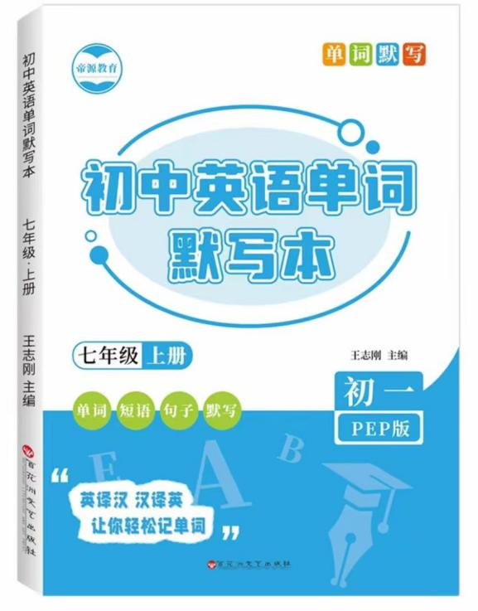
视频同款学习资料
想要的家长看主页橱窗
选中小学教辅图书
全网搜“帝源教育”

【翻译】
我的朋友
我有一个好朋友。她叫温迪。她出生在美国，但现在住在中国。她今年13岁。她就读于第一中学，学校很大也很漂亮。她的教室在一楼，干净又明亮。她个子高，长得漂亮，而且不戴眼镜。她擅长画画和游泳。她还是学校读书俱乐部的成员。
温迪想成为一名英语老师，因为她想帮助贫困地区的孩子们。我希望她的梦想有一天能实现。我觉得温迪真的是一个善良又聪明的女孩。我非常喜欢她。

