八年级英语上册第一次月考作文押题及范文
押题作文（一）
今年暑假，你跟你的爸爸一起去四川度假。假如在8月4日（星期一）这天，你们去了峨眉山，并参观了动物园，看到很多大熊猫。请根据以下问题提示，写一篇日记，描述当天的情况。
提示：
1. How was the weather?
2. Where did you go?
3. Who did you go with?
4. What did you do?
5. How did you feel about the trip?
【范文】
Monday, 4th August
It was sunny and hot today. l went to Sichuan with my father
We went to Mount Emei. The scenery was really beautiful. Then we visited the zoo and saw pandas. They are my favouriteanimals because they're so cute. l think we should try our best to protect them. For lunch, we had hot pot. lt was delicious. In theevening, we went shopping and l bought something for my friends. Everything was excellent.
We were tired but happy. lt was worth visiting. l hoped to go there again.
【翻译】
8月4日，星期一
今天阳光明媚，天气炎热。我和爸爸去了四川
我们去了峨眉山。风景真的很美。然后我们参观了动物园，看到了熊猫。它们是我最喜欢的动物，因为它们太可爱了。我认为我们应该尽力保护他们。午饭我们吃了火锅。很好吃。晚上，我们去购物了，我给朋友买了些东西。一切都很好。
我们很累，但很开心。它值得一游。我希望再次去那里。
八年级英语上册第一次月考作文押题及范文
押题作文（二）
假如你是李华，你的美国笔友Eric给你发来邮件，想了解你在暑假期间的学习和生活情况。请你根据以下提示，给Eric回一封邮件。
1.每天的学习安排；2.周末的活动；3.你的暑假感受或收获。
【范文】
Dear Eric,
I' m so happy to receive your email. You wanted to know about my study and life during the summer holiday, so let me tell you.
Every day, l had a regular study plan. In the morning, l spent an hour reading storybooks and finished my summer homework.
In the afternoon, took online English classes to practice speaking. lt's fun to learn with foreign teachers!
On weekends, l never stayed at home all day. Sometimes my family and l went to the park to ride bikes. l also helped my momwash dishes or clean my room, She always said l was more responsible.
This summer, l not only made progress in English but also learned to manage my time wel. l feel relaxed and meaningful. Howwas your summer holiday?|' m looking forward to your reply.
Best wishes,
Li Hua
【翻译】
亲爱的Eric：
我很高兴收到你的电子邮件。你想知道我暑假期间的学习和生活，所以让我告诉你。每天，我都有一个定期的学习计划。早上，我花了一个小时读故事书，完成了暑期作业。下午，参加了网上英语课练习口语。和外教一起学习很有趣！周末，我从不整天呆在家里。有时我和家人去公园骑自行车。我还帮妈妈洗碗或打扫房间，她总是说我更负责任。
今年夏天，我不仅在英语方面取得了进步，还学会了如何管理时间。我感到放松和有意义。你的暑假过得怎么样？我期待着你的回复。
致以最美好的祝愿
李华
八年级英语上册第一次月考作文押题及范文
押题作文（三）
家是我们幸福温暖的港湾。请以“My Home and Housework”为题，写一篇短文，描述你在家中的生活以及你和家人做家务的情况，并阐述家庭和做家务对你的意义。
注意：
(1)词数80~100，标题已给出，不计入总词数;
(2)可适当增加细节，以使行文连贯;
(3)文中不能出现真实姓名及学校名称。
【范文】
My Home and Housework
My home is a warm place. My family members share housework. Mum cooks and cleans for us. We are happy to have deliciousdishes and wear clean clothes. Dad fixes things. How capable my father is! l take out the rubbish and fold clothes. Although theyare small things, !’m proud that l can do something for my family. Doing housework makes me responsible. it also helps meunderstand my parents better. l decide to study harder and harder. Home is a place where love is shown through these smallthings, and it gives me a strong sense of belonging.
【翻译】
我的家和家务
我家是个温暖的地方。我的家人分担家务。妈妈为我们做饭和打扫卫生。我们很高兴能吃到美味的菜肴，穿上干净的衣服。爸爸修理东西。我父亲多么能干啊！我倒垃圾，叠衣服。虽然它们是小事！我很自豪能为我的家人做点什么。做家务让我有责任感。这也有助于我更好地了解我的父母。我决定越来越努力地学习。家是一个通过这些小事表达爱的地方，它给了我强烈的归属感。
八年级英语上册第一次月考作文押题及范文
押题作文（四）
假设你是李华，你的英语老师MissLi想了解同学们日常做家务的情况。请你根据以下内容提示，用英语写一封信，告诉MissLi你做家务的情况。
提示：
1.你做家务的时间；
2.你做的具体家务（至少四项）；
3.你对做家务的感想。
【范文】
Dear Miss Li,
How are you? I'd like to tell you something about chores that I do. l usually do chores on weekends and sometimes aftelschool. Every day, l make my bed, water the plants, and take out the trash. On weekends, l help my parents clean the house, washthe dishes, and fold the laundry.l also feed our pet dog.
I think doing chores is important because it helps me learn responsibility. lt also makes me feel happy to help my family.
Yours,
Li Hua
【翻译】
亲爱的李：
你好吗？我想告诉你一些我做的家务。我通常在周末做家务，有时在放学后做。每天，我整理床铺，给植物浇水，倒垃圾。周末，我帮父母打扫房子、洗碗、叠衣服。我还喂我们的宠物狗。
我认为做家务很重要，因为它能帮助我学会责任。这也让我很高兴能帮助我的家人。
你的，李华
八年级英语上册第一次月考作文押题及范文
押题作文（五）
假如你是吉米，你的好朋友萨姆要搬进新居，他想向你咨询关于卧室装修的建议。请根据邮件内容和你所学的关于颜色的知识回复邮件，表达你的建议。
Hi, Jimmy,
You know my family will move into a new flat next spring. We’re decorating it now. I want to make my bedroom a comfortable place because I often feel tired and stressed after school. What colour should I paint the wall? What can make me feel energetic (精力旺盛的)? Could you please offer me some advice?
I’m looking forward to your reply.
Yours,
Sam
写作要求：
（1）要点齐全，可适当增加细节，以使行文连贯；
（2）词数不少于100（开头和结尾已给出，不计入总词数）。
【范文】
Dear Sam,
I’m so glad that you will move into a new flat with your own bedroom.
A bedroom should make you feel relaxed, so l think it might be a good idea to paint the wallight blue. Blue can bring peace toyour mind and body. As a middle school student, you always have much pressure and feel stressed easily. So blue is the bestcolour. As too much schoolwork makes you feel tired easily, you need energetic colours in the bedroom. You'd better put somegreen plants in your bedroom. You can also hang some pictures of nature on the wall. lt’s also a good idea to put some flowers bythe window, They can make the room full of life and make you feel energetic.
I hope my advice will be helpful and that you will enjoy your new life!
Yours,
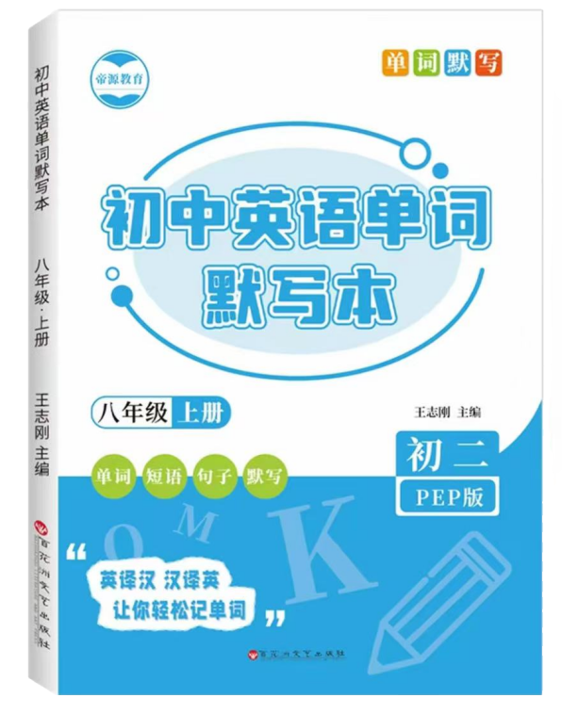
Jimmy
视频同款学习资料
想要的家长看主页橱窗
选中小学教辅图书
全网搜“帝源教育”

【翻译】
亲爱的山姆：
我很高兴你要搬进一套有自己卧室的新公寓。
卧室应该让你感到放松，所以我认为把墙漆成淡蓝色可能是个好主意。蓝色可以给你的身心带来平静。作为一名中学生，你总是有很大的压力，很容易感到压力。所以蓝色是最好的颜色。由于太多的功课会让你很容易感到疲倦，你需要在卧室里使用充满活力的颜色。你最好在卧室里种些绿色植物。你也可以在墙上挂一些自然的照片。在窗户旁边放些花也是个好主意，它们可以让房间充满活力，让你感到精力充沛。
我希望我的建议会有所帮助，你会享受你的新生活！
你的，吉米

